**Computer Science Controlled Assessment**

**Task One**

**Introduction**

The first task I will be attempting is a program that enables students to practice their arithmetic skills. In order for them to practice their arithmetic skills I will create a code. The code will ask the student their name. Then it will pick two different numbers then pick one of the following: addition, subtraction and, multiplication. Then ask a question with the two numbers and question type selected by the program. If the numbers one and two are picked also addition is chosen to be the question type then the question should look like this “What is 1 + 2 = “. The student will be prompted to answer the question if they get the question correct it will tell them whether they got it correct or not. The program will ask the student ten different questions. At the end of the ten questions the program will inform the student of their score.

**Success criteria**

In order for the program to run as expected there are several criteria’s it will be required to meet, they are listed below:

* The program will ask the user of their name.
* The user will not be able to skip questions
* It will ensure that a valid name is given.
* The program will run fully without giving a logic, syntax or runtime error.
* The program will prompt the user to enter a number if the answer they provide to the question is not a number.
* The student will be informed whether their answer was correct at the end of each question in the code.
* At the end of the code the student score out of 10 will be displayed.
* If the student makes a typo in their name they can renter their name.
* The program will ask the student a total of ten questions.

**Algorithm**

Numbers ["0","1","2","3","4","5","6","7","8","9","10"]   
Score 0   
Type ["x","-","+"]  
Question 10  
Num1 0  
Num20  
QT 0  
checkname 1

OUTPUT “Welcome student”

OUTPUT “This quiz will test your math skills”

OUTPUT “You will have 10 questions”

INPUT Name

WHILE checkname = 1  
 Output ”Is”, Name, “your name”  
 INPUT namecheck1  
 namecheck = namcheck1.lower  
 IF namecheck = yes  
 checkname0  
 ELSE IF namecheck = no  
 INPUT Name   
 ELSE   
 OUTPUT “Invalid answer”  
 OUTPUT “If it is type yes if its not type no  
 END IF  
END WHILE  
  
FOR i FROM 1 TO 10  
 OUTPUT “You have”, Question, “Questions”  
 Question Question – 1  
 Num1 random(0,10)  
 Num2 random(0,10)  
 QT  random(0,2)  
 OUTPUT “What is”, Numbers[Num1], Type[QT], Numbers[Num2], “?”  
 WHILE TRUE  
 TRY  
 INPUT ans  
 BREAK  
 EXCEPT ERROR  
 OUTPUT ”Not a valid answer”   
 IF QT = 0   
 Ans1  Num1 * Num2  
 ELSE IF QT = 1  
 Ans1  Num1 – Num2  
 ELSE IF QT = 2  
 Ans1  Num1 + Num2  
 END IF   
 IF Ans1 = ans  
 OUTPUT “Well done”  
 Score Score + 1   
 OUTPUT “Your Score is”, Score  
 ELSE   
 OUTPUT “That’s wrong”  
 OUTPUT ”The answer is”, Ans1  
 OUTPUT “Your Score is”, Score

IF namecheck = yes

ELSEIF

END IF

END FOR

IF Score = 10  
 OUTPUT "Well done you got everything correct! With a score of", Score  
ELSE IF Score = 9  
 OUTPUT "You got most correct, with a score of", Score  
ELSE IF Score = 8  
 OUTPUT "You got most correct, with a score of", Score  
ELSE IF Score = 7  
 OUTPUT "You got most correct, with a score of", Score  
ELSE IF Score = 6  
 OUTPUT "You got most correct, with a score of", Score  
ELSE IF Score = 5  
 OUTPUT "You got half correct, with a score of", Score  
ELSE IF Score = 4  
 OUTPUT "You got some correct, with a score of", Score   
ELSE IF Score = 3  
 OUTPUT "You got some correct, with a score of", Score  
ELSE IF Score = 2  
 OUTPUT "You got some correct, with a score of", Score  
ELSE IF Score = 1  
 OUTPUT "You got some correct, with a score of", Score  
ELSE IF Score = 0  
 OUTPUT "Unlucky got none correct, with a score of", Score

**Justification of approach**

In this section I will be justifying the approach I will be taking to make the code. At the beginning I will have a list of one to ten and the operation addition, subtraction and, multiplication. The reason I will be using lists is to enable me to pick a random value to form a question for the student.

In the main bulk of the program I will use a while loops at the part in which the student enters their name. I will use them to ensure that the student enters a valid name also to ensure that the student has not made a typo in the name they provided in the program.

When the program asks the students the arithmetic question I will use a for loop, this will enable the code to ask the students 10 questions without me having to copy the section in which the question is asked 10 times. The reason I will use a for loop instead of a while loop is because a for loop is a count control loop unlike a while loop which is a condition loop meaning it will keep running the loop until a condition is met.

I will use a variable, Score, to store how many questions the student has gotten correct. The reason I will use a variable is so that I can print the students score at the end of the program also when they have answered the question. A variable is the only way for me to store a value that will be changed in the program; that is another reason I am using it.

I will use the random function in the main bulk of my code to choose the two numbers also the operation. The reason I will use a random function is to enable the code to randomise the questions given to the student.

**Variables**

|  |  |  |
| --- | --- | --- |
| **Name of the variable** | **The type of data the variable is** | **What I will use the variable for** |
| Score | Integer | This variable will be used to save how many questions the student has gotten correct. |
| Numbers | List | Will be used to store the numbers which will be randomly picked from. |
| Type | List | This will store the operations which will be randomly picked during the main code. |
| Question | Integer | This will store how many questions the program has asked the user. |
| checkname | Integer | Will be used to check whether user has entered their correct name. |
| Num1 also Num2 | Integer | Will be used to store the randomly picked numbers. |
| QT | Integer | Standing for question type. This will store the randomly picked operation. |
| Name | String | This will be used to store the student’s name. |
| Ans | Integer | This will store the answer in which the student provides for the question asked. |
| namecheck | String | Will store namecheck1 but with all the letters in lower case. |
| namecheck1 | String | Will be used to store the response which the student enters when they asked whether the name they asked was correct |
| Ans1 | Integer | Will be used in order to store the actual answer to the question. |

**Validation**

Throughout the code I will be validating parts; this will enable me to meet my success criteria. Below they are listed.

1. The answer the user enters to the questions needs to be a valid number, if they do not they will be prompted to enter a something else.
2. The name the user enters cannot just have a space, a number, or nothing written. If the user does this they will be made to enter their response again.

**Test Plan**

To ensure the program is able meet my success criteria I will need to test several aspects of the program.

|  |  |  |  |
| --- | --- | --- | --- |
| No | Test | Test Data | Expected outcome |
| 1 | The user cannot skip questions. | **Normal:** Numeric data  **Erroneous :** “Five”  User presses enter to skip question. | **Normal:** If the answer given by the student is “normal data” it should continue with the program.  **Erroneous:** if it is not then it should prompt the user to enter a new answer and continue to do so until they have entered “normal data”. |
| 2 | The name given to the program by the student must not be a number, just a space or, have no characters in it at all. | **Normal**: “Lewis”, “James”,  “Bony” and “Johnny”.  **Erroneous:** “ “ (input with only space), ”1”(input where only a number is written) and,””(input with nothing written). | **Normal:** If the response given by the student is acceptable then the program should progress onto the next section, ensuring that the name the student inputted is stored under the variable “Name”.  **Erroneous:** If the response given is erroneous then the program should prompt the user correct data, it should continue to do this until correct data is given. |
| 3 | The answer provided by the student to the questions must be a number | **Normal**: Numerical response  **Erroneous:** “”, “b”, “ “. | **Normal:** program should continue to the next section.  **Erroneous:** user should be made to answer the question again and continue to do so until they have entered acceptable answer. |
| 4 | After each question and at the end of the program should print the users score | **Normal:** The questions need to be answered after each answer score should be printed. At end of program the total score should be printed, it should be the same as the total of the scores printed. | **Normal:** When user gets score correct the variable score should be added by one then printed at end of program. When user finishes questions the user should be told their final score. |
| 5 | When user gives valid name they should be asked to verify name is correct. | **Normal: “**yes””no”  **Erroneous:** “Hello”,”Jim” | **Normal:** If they say no it should make them retype it until they answer yes. If user answers yes program should run the next section.  **Erroneous:** User should be asked to answer question again. |
| 6 | Test code asks student ten questions. | **Normal:** Code ask 10 questions | **Normal**: When program is run the student will be asked ten question |

**Development**

In my program I used several comments to show step by step what each section of the code is doing.

On the third line I used the “**import random**”. This enabled the code to randomly select two numbers also an operation.

The lines five to twelve contain the variable I will be using in the program.  
-The first variable I inserted was “Score”. This variable is used to store the students score.  
-The second and third variables I used were lists named “Numbers” and “Type”. These variable stored the numbers 1-10 and stored the three operations that will be used within the program.  
-Variable four stores how may question the student has left  
-The fifth variable is used to check whether user has not made a typo in their name.  
-The rest of the variable are used to store things in the program such as the randomly selected numbers and the randomly selected operation.

The lines fourteen to eighty-nine is the main section of the program.  
-Lines 18-21 ask the user their name and verifies that the name the user enters does not meet the requirements: “not a number”, “not just a space” finally, “has no characters”. If it does meet the requirements then the user is then prompted to enter their name again  
-On the lines 23-38 the programs prints the name the user enters and asks them whether it is correct . If the user says yes then the program progresses on to line 41. If the user enters no the then the user is prompted to enter their name again. The name is then checked to ensure it is valid. Then the whole process is repeated again.  
-Line 48-77 is the part in the program in which the user is tested by asking 10 questions. In line 48 the ***for*** function is used to repeat the section ten times. This enables the user to be asked ten questions. Two random numbers between 0 and 10 are then picked in lines 52 and 54 then one more is chosen between 0 and 2. These numbers are stored in the variables “QT”, “Num1” and, “Num2”. Line 55 then formulates a question. It does it by using the randomly generated numbers to take numbers out of the variable named ,Question, then takes an operation from the variable, Type, using the randomly generated number. Lines 56-62 uses the try and except function to ensure the user enters a valid number to the question answered on line 55. Lines 64 – 72 calculate the answer to the question asked on line 55 using the ***if*** and ***elif*** python functions. It checks what operation was chosen then find the solution to the question. The lines 73-80 check if the answer the user gave equated to the answer the program calculated then the users score will be added to by one. Then the user is told they got the question correct and their score is printed. If the user get answer incorrect they are told that answer is wrong, then told the correct answer and, finally informed of their score.

The final part of the program is lines 73-96. In this section the user is told their final score followed by some motivational speech. If the user got 10/10 they are told “Well done you got everything correct!”, if the user got a score between 6 and 9 they are told "You got most correct, with a score of", if the user got a score of 5 they are told "You got some correct, with a score of", if they got a score of 1-4 they will be told "You got some correct, with a score of" and, finally if they got a score of 0 they are told "Unlucky got none correct, with a score of".

**Final Code**

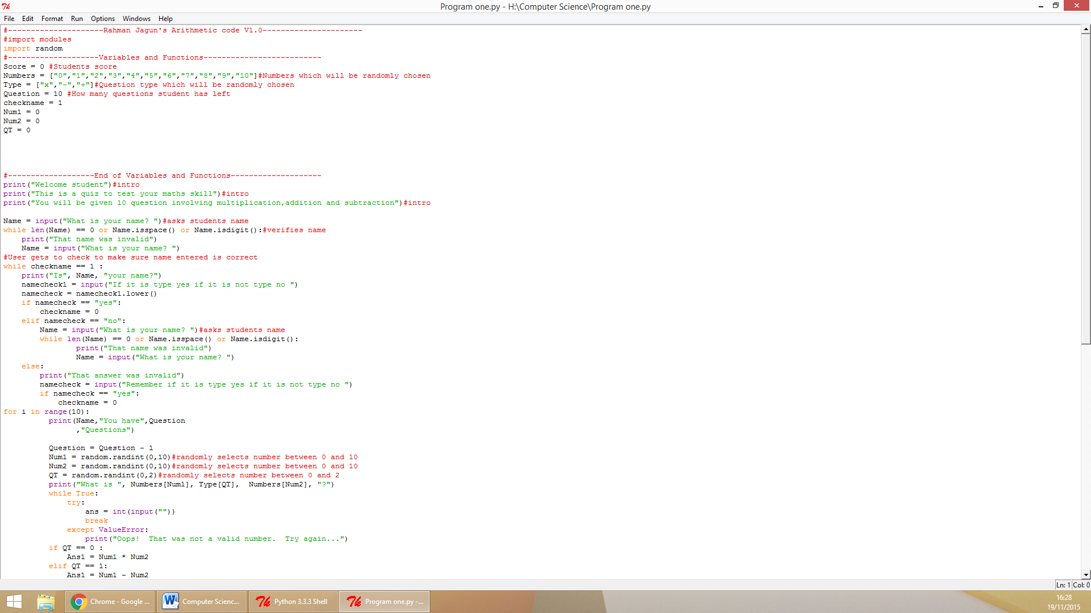

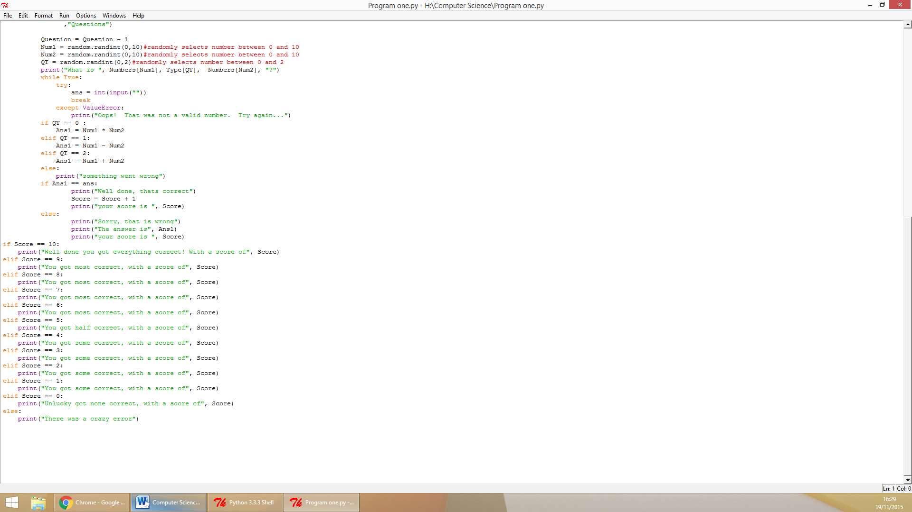

**Testing during development**

I ran several test during the development of the program below are the errors I encountered and how I managed to solve them.

Syntax error

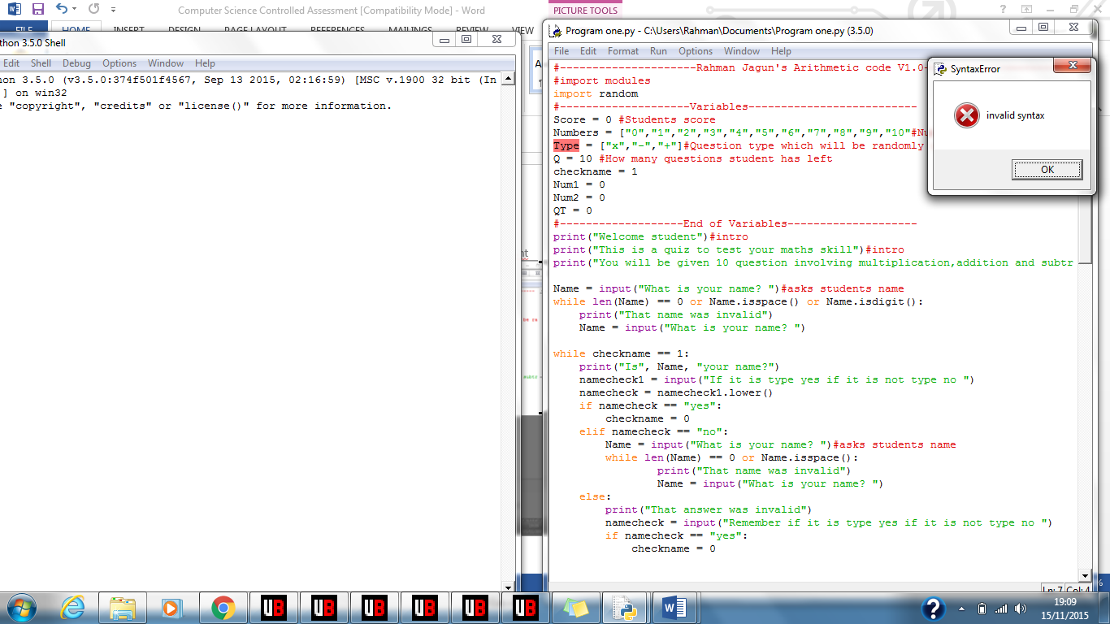

This was the first error I got, a syntax error. When I ran the code the program said invalid syntax. The “Type” was highlighted in red. A syntax error means there is something missing in the program that is preventing it from. Due to the type being highlighted I looked at the line above it then realised I had forgotten a square bracket in the variable “Numbers”. If fixed by adding the square bracket shown below.  
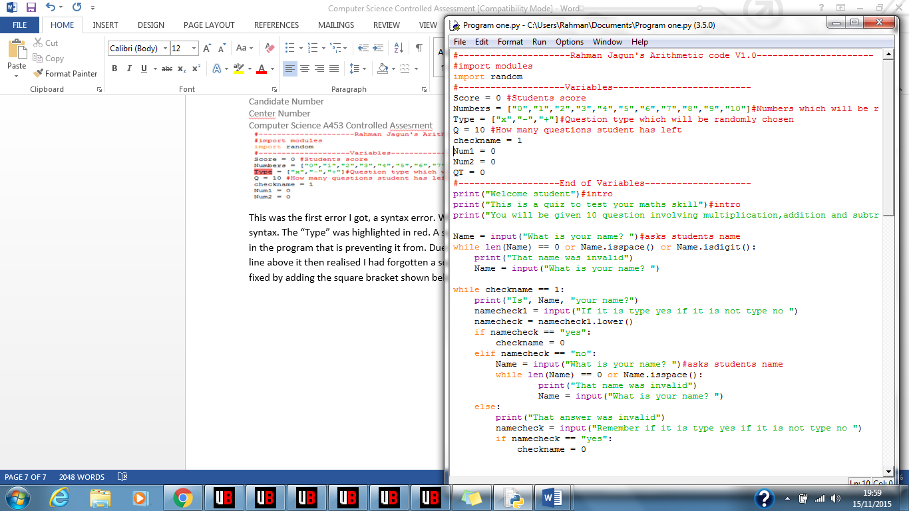

Runtime Error

The second error I receive was this:   
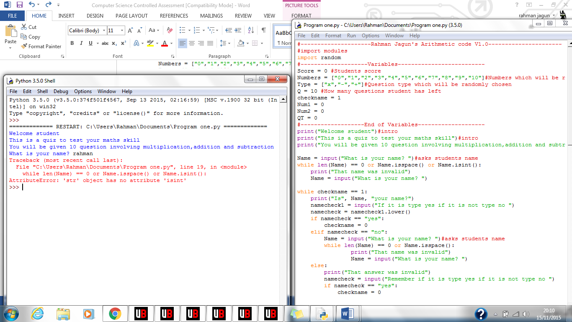  
This was a runtime error. I used a non-existent python function “isint()” to attempt to check whether the user entered just a number in their response. In order for me to amend this error I change the “isint()” funtction to an existing python function call “isdigit()”. Below is the amended code.  
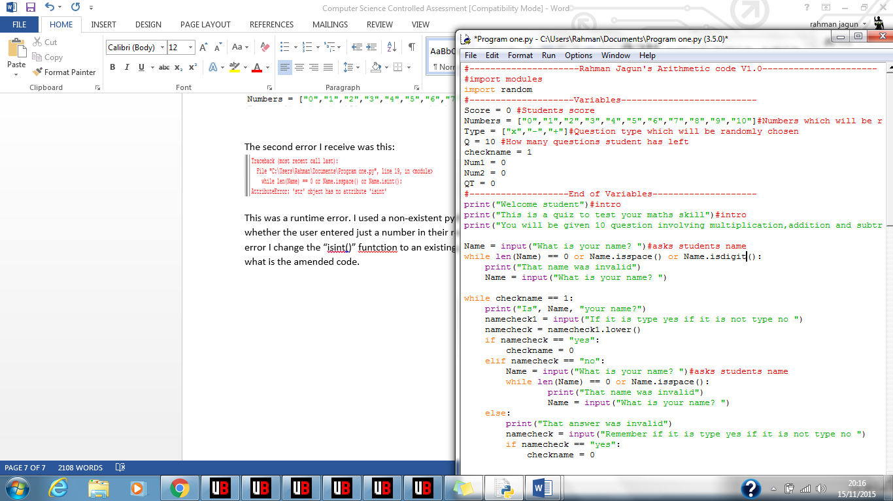

Runtime error

The third error I came across when testing the code was:

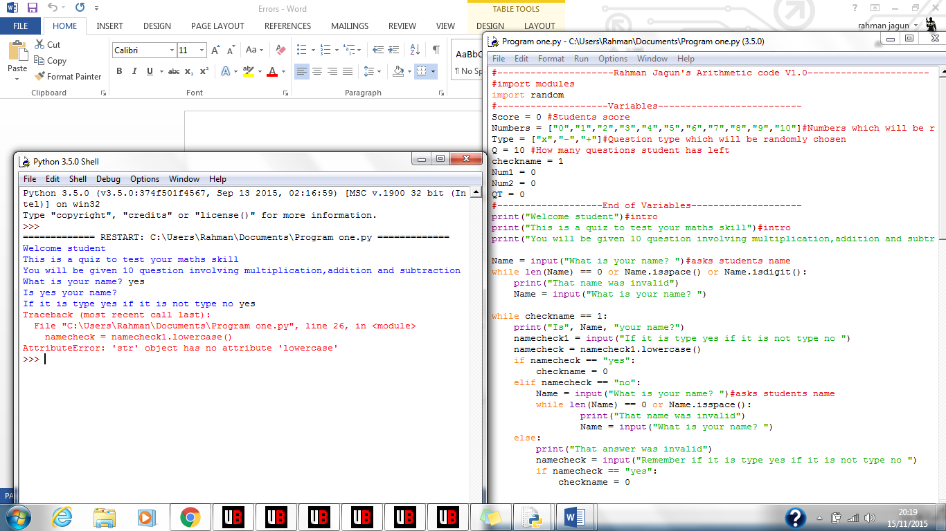

This error occurred due to me, again, attempting to use an incorrect python function by the name of “lowercase()”. The correct python function was in fact “lower()” I changed it to the correct function and ran it then the code ran to the next line without an error. Here is the corrected line:  
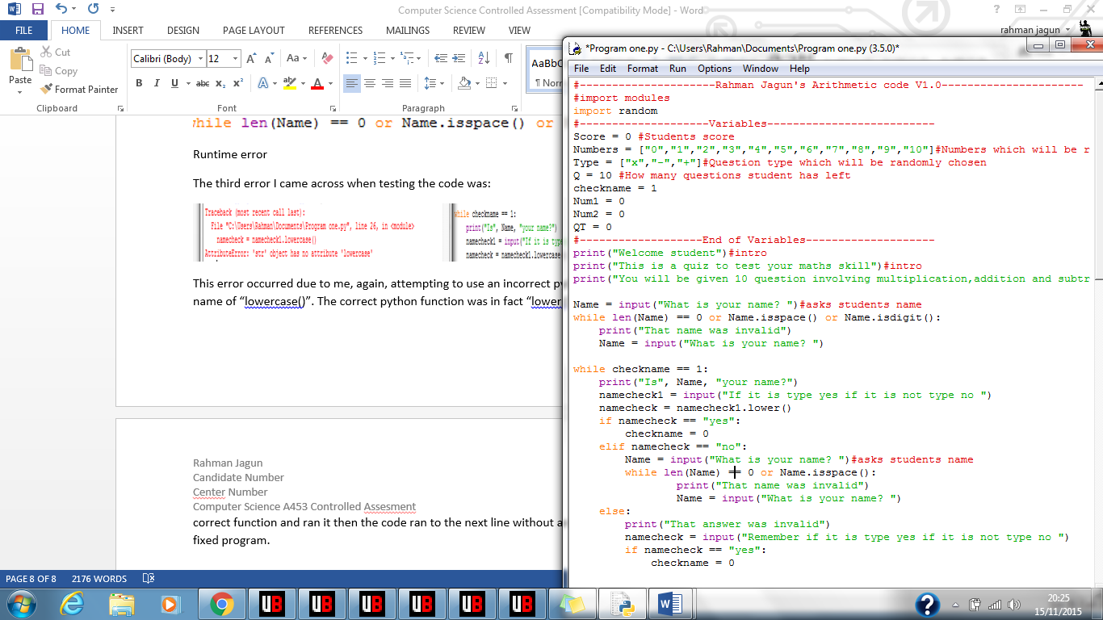

Logic error  
The third error I got was this:

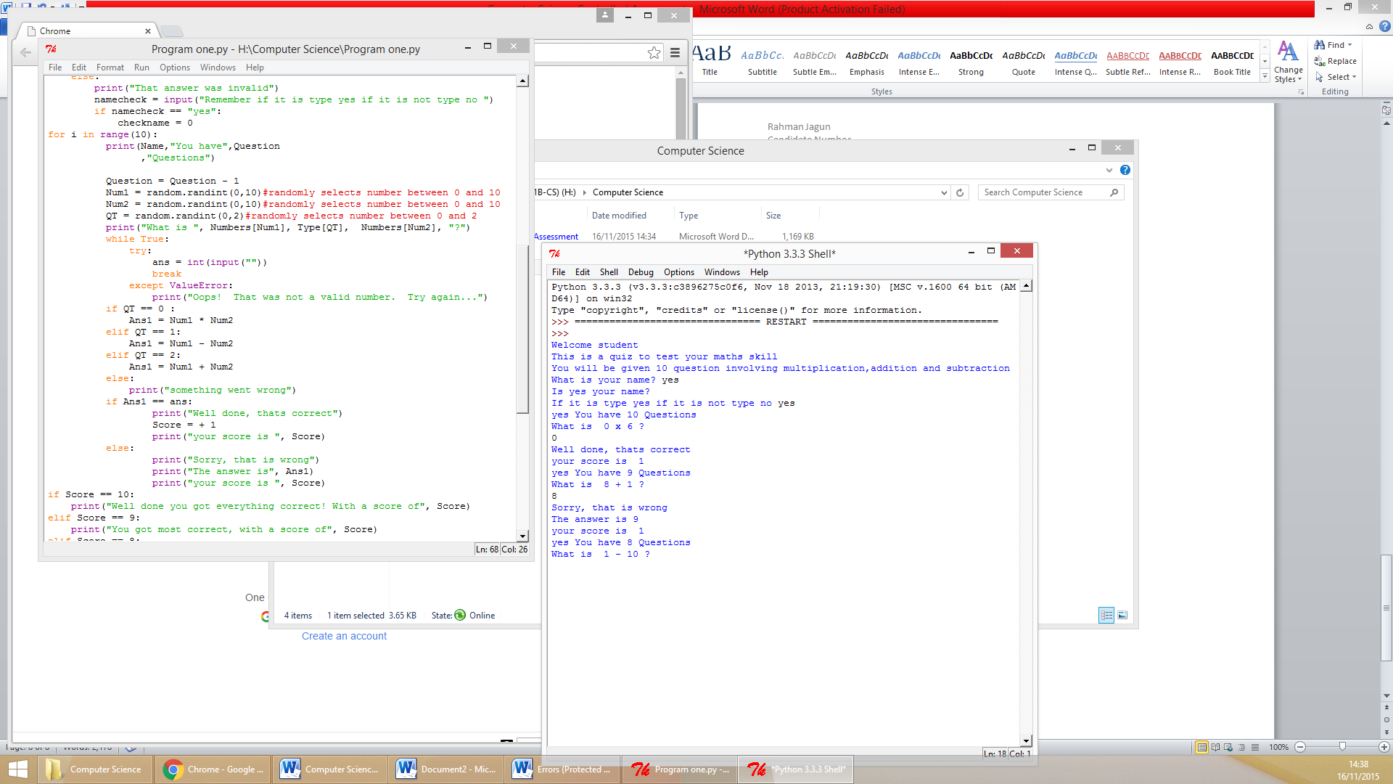

Instead of increasing the score by one when user got answer correct it made the score the score one. This is a logic error. The program ran without displaying an error however the section never ran how it was intended to. The reason I received this error was because when the user got answer correct the variable “Score” was changed to “+1” instead of it being added by one. To amend this error I when user go answer correct I changed “Score = +1” to “Score = Score + 1”. When I the program after the edit the code functioned as intended, when user got answer correct the score was added to by one.

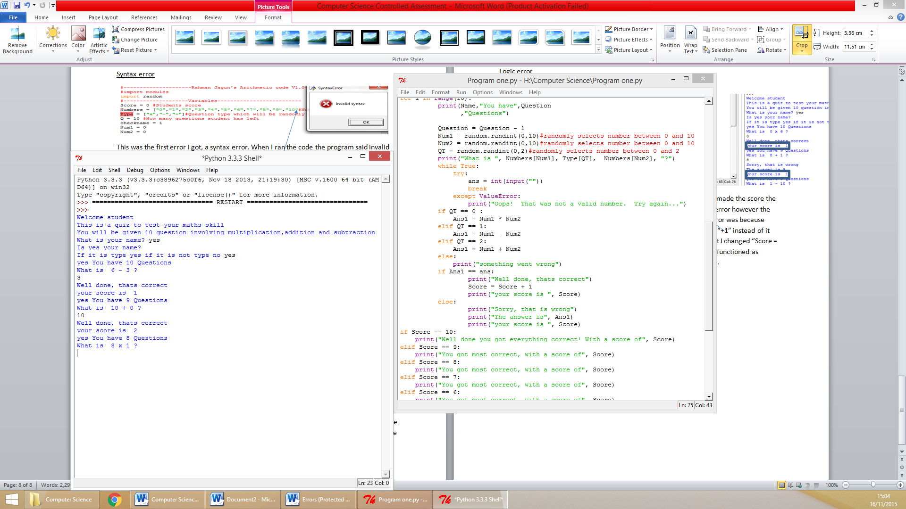

Syntax error  
The fourth error I got was this:

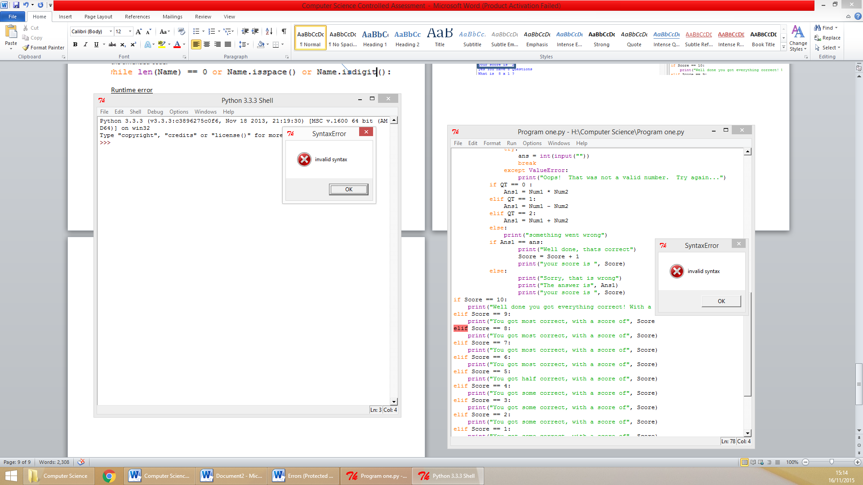This was the final error I got. It was a syntax error was caused due to a missing bracket in the line above to close the print. To fix this error I put the missing bracket then ran the code and it never gave a syntax error. It is shown below.  
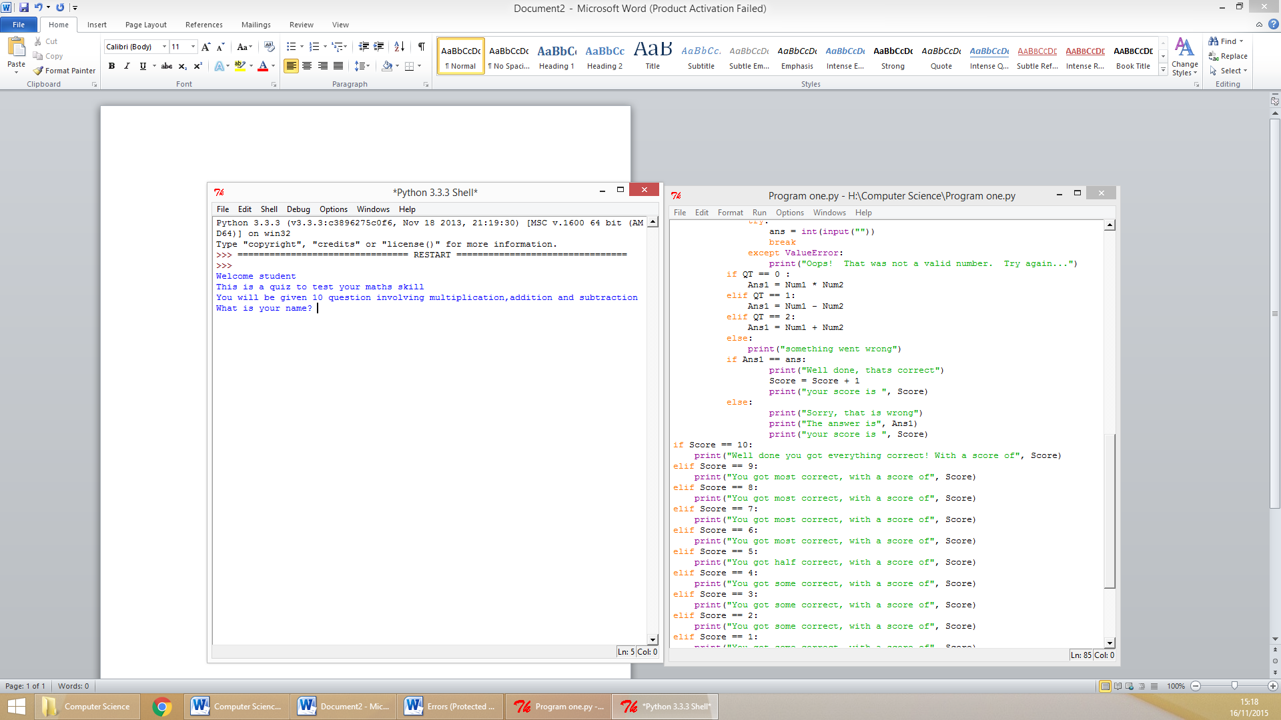

**Testing**

To ensure my success criteria’s were met I made several other tests on the program I created below is the test plan.

|  |  |  |  |
| --- | --- | --- | --- |
| No | Test | Test Data | Expected outcome |
| 1 | The user cannot skip questions. | **Normal:** Numeric data  **Erroneous :** User presses enter to skip question. | **Normal:** If the answer given by the student is “normal data” it should continue with the program.  **Erroneous:** if it is not then it should prompt the user to enter a new answer and continue to do so until they have entered “normal data”. |
| 2 | The name given to the program by the student must not be a number, just a space or, have no characters in it at all. | **Normal**: “Lewis”, “James”,  “Bony” and “Johnny”.  **Erroneous:** “ “ (input with only space), ”1”(input where only a number is written) and,””(input with nothing written). | **Normal:** If the response given by the student is acceptable then the program should progress onto the next section, ensuring that the name the student inputted is stored under the variable “Name”.  **Erroneous:** If the response given is erroneous then the program should prompt the user correct data, it should continue to do this until correct data is given. |
| 3 | The answer provided by the student to the questions must be a number | **Normal**: Numerical response  **Erroneous:** “”, “b”, “ “. | **Normal:** program should continue to the next section.  **Erroneous:** user should be made to answer the question again and continue to do so until they have entered acceptable answer. |
| 4 | After each question and at the end of the program should print the users score | **Normal:** The questions need to be answered after each answer score should be printed. At end of program the total score should be printed, it should be the same as the total of the scores printed. | **Normal:** When user gets score correct the variable score should be added by one then printed at end of program. When user finishes questions the user should be told their final score. |
| 5 | When user gives valid name they should be asked to verify name is correct. | **Normal: “**yes””no”  **Erroneous:** “Hello”,”Jim” | **Normal:** If they say no it should make them retype it until they answer yes. If user answers yes program should run the next section.  **Erroneous:** User should be asked to answer question again. |
| 6 | Test code asks student ten questions. | **Normal:** Code ask 10 questions | **Normal**: When program is run the student will be asked ten question |

Test Number One:  
 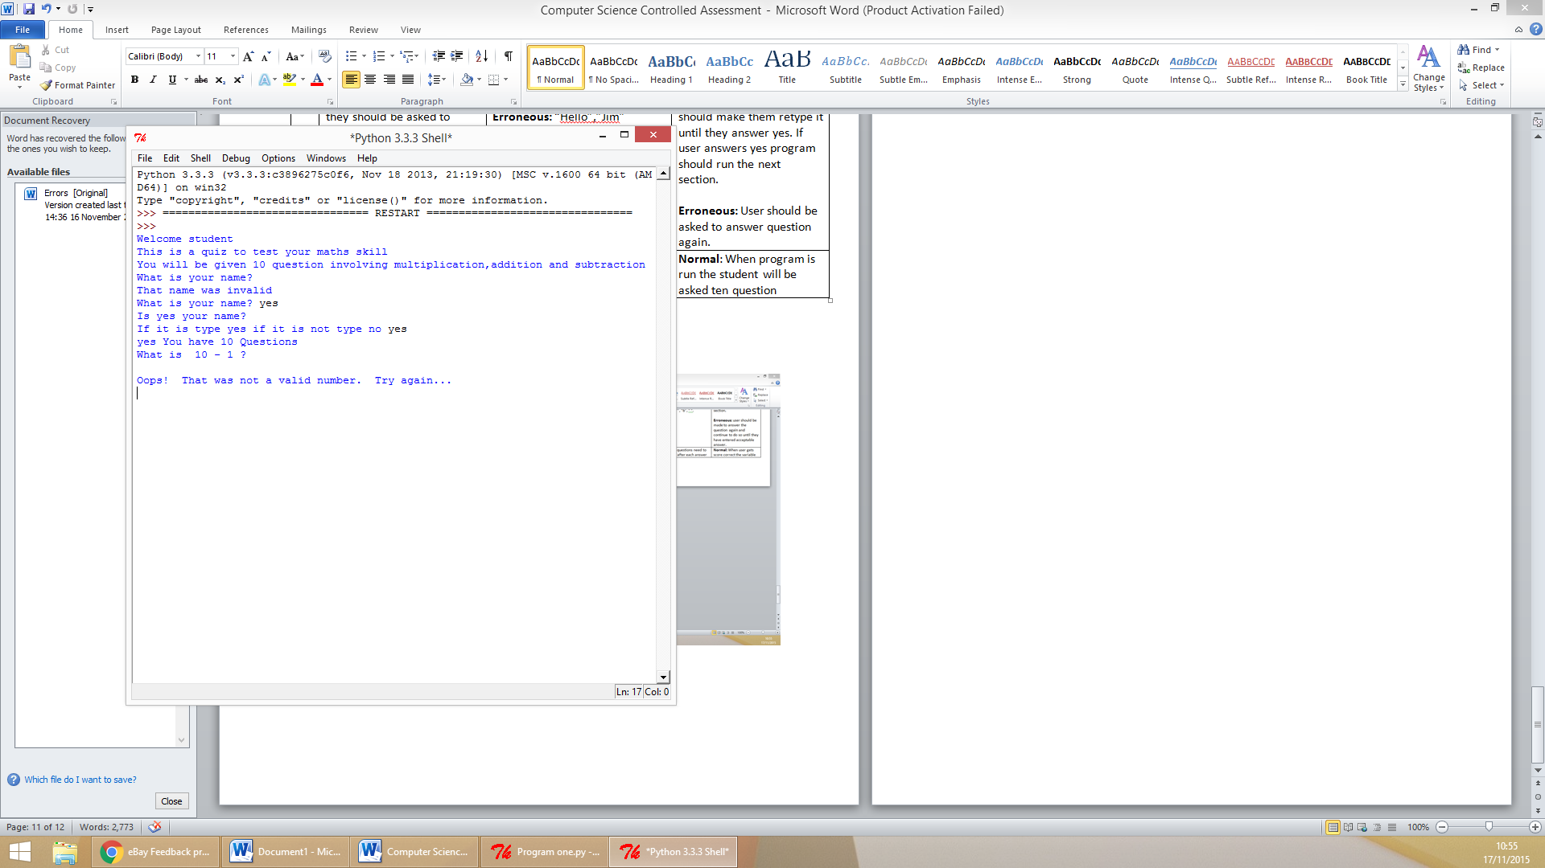  
Above it shows what happens when user presses enter in an attempt to skip the question. When they presses enter instead of answering question the program tells the user it is not a valid response and they are prompted to enter a response until they answer the question suffice enough. Below are the two sections of the program that ensures the user cannot skip a question.

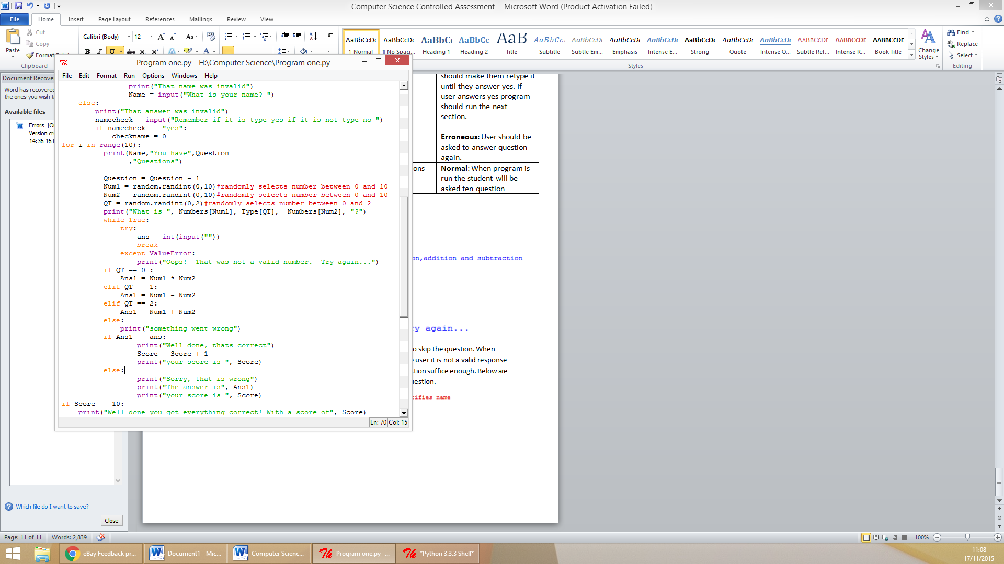

Because my program prevents the user from skipping questions the **PASSED** this test plan.

Test Number Two:

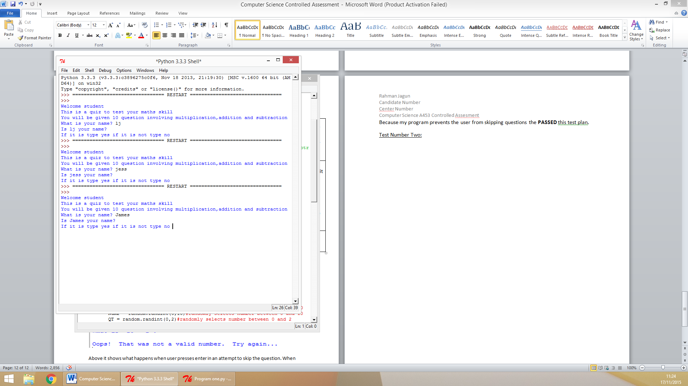

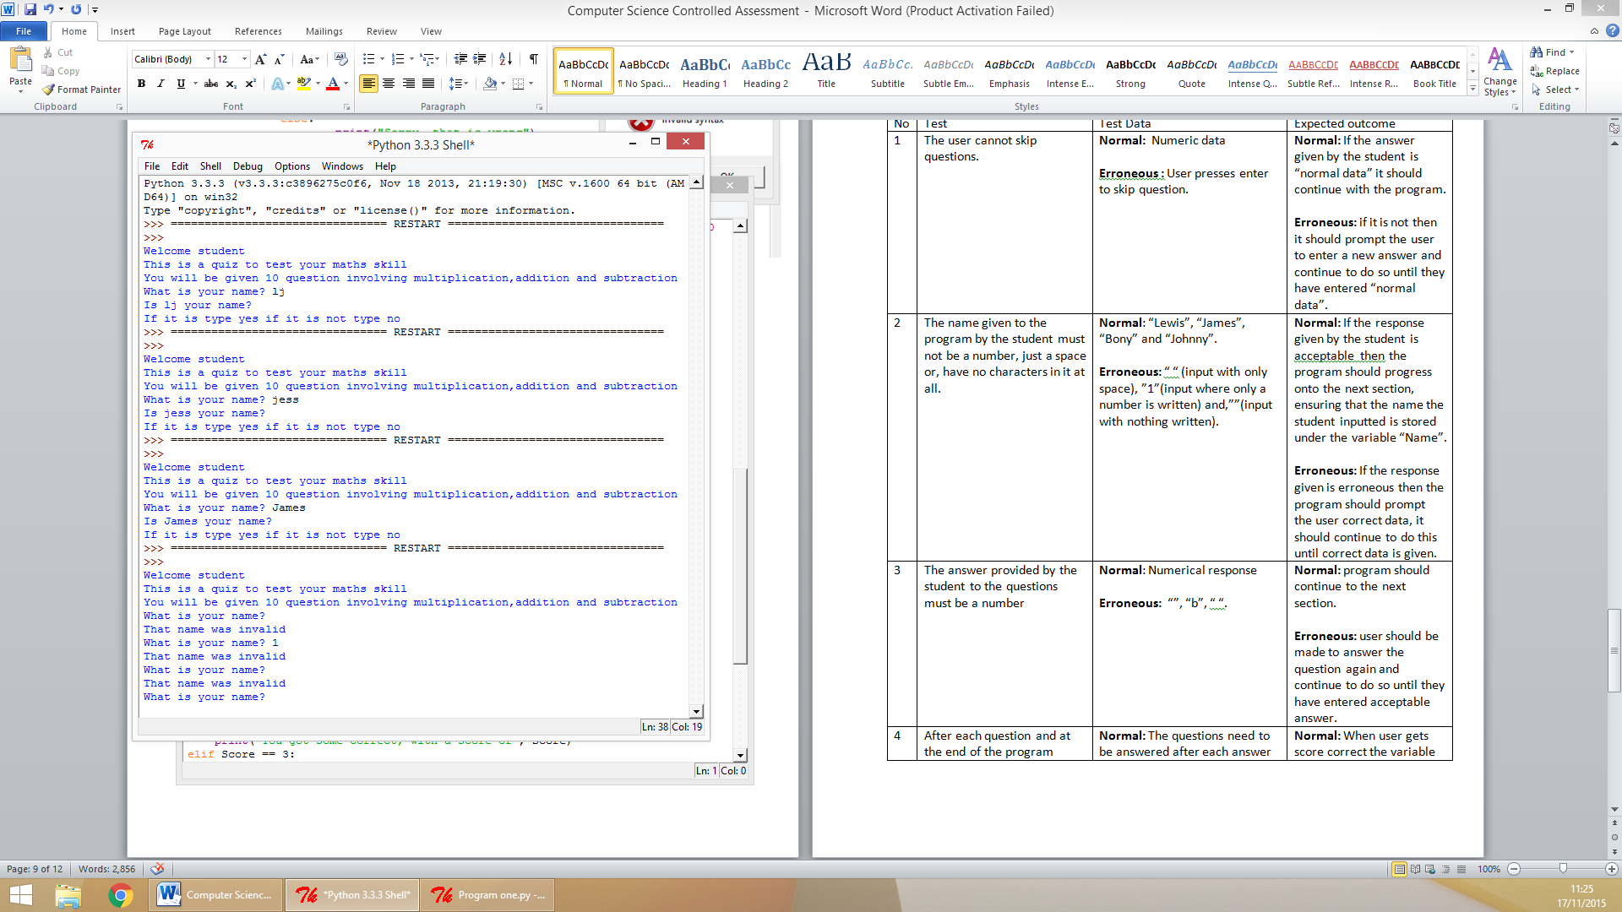

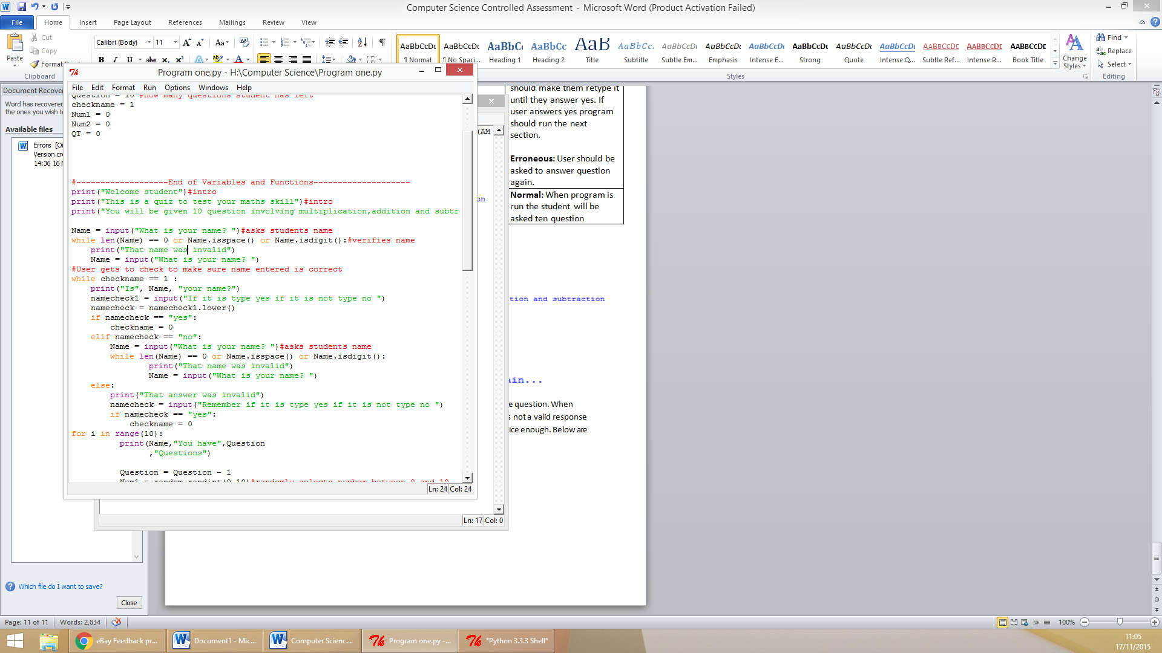

Above is screenshots of how I put that test plan two into action. The first screenshot shows the program accepting an example of normal data and continuing to the next program. The second screen shot shows what happens when the user enters an example of erroneous data, the program prompts them to enter a valid name. The third screenshot shows the program used to ensure that this test is passed. Because the program does what it supposed to upon receipt of erroneous also normal data the program gets a **PASS** on test number two.

Test Number Three:  
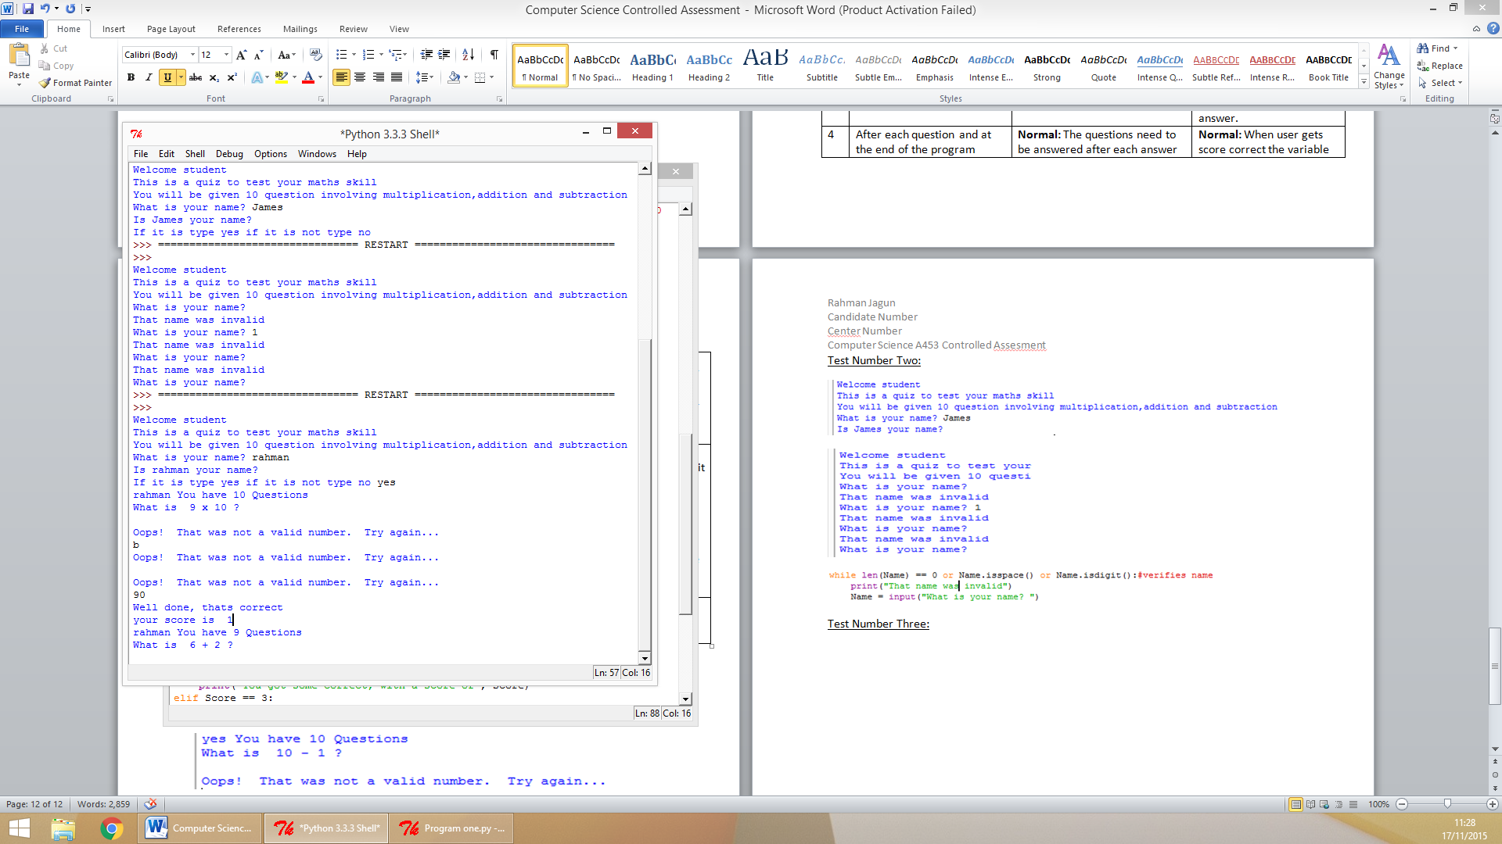



The screenshots on top show what happens when the user enters erroneous and normal form of data. If the user enters a form of unacceptable data then they are prompted to enter another answer until the response given is a form of acceptable data (numerical). This means the program PASSED this aspect of the test plan as the user as the program does not accept anything but a numerical response to questions answered in the quiz.

Test Number Four:

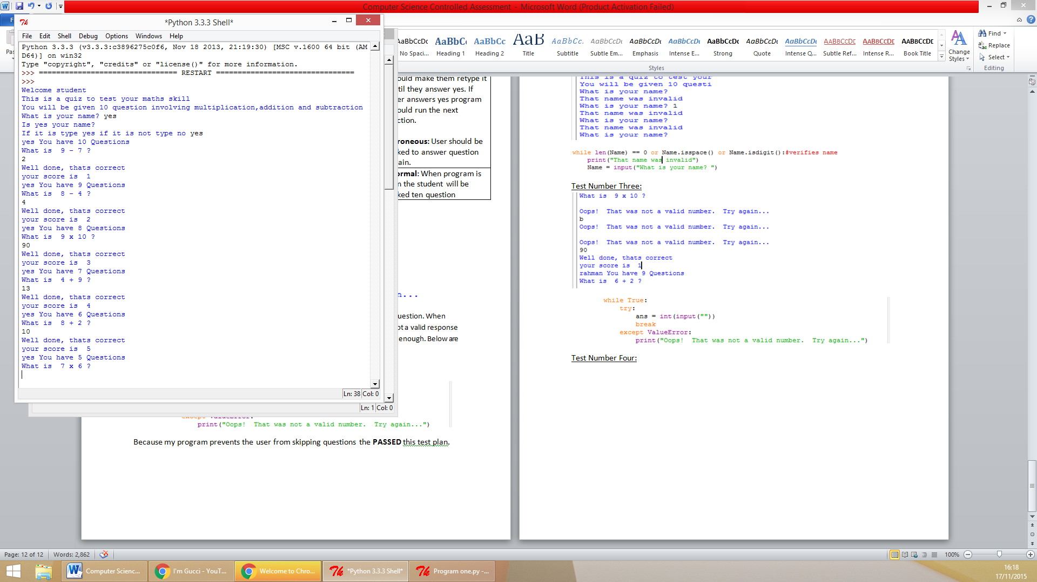

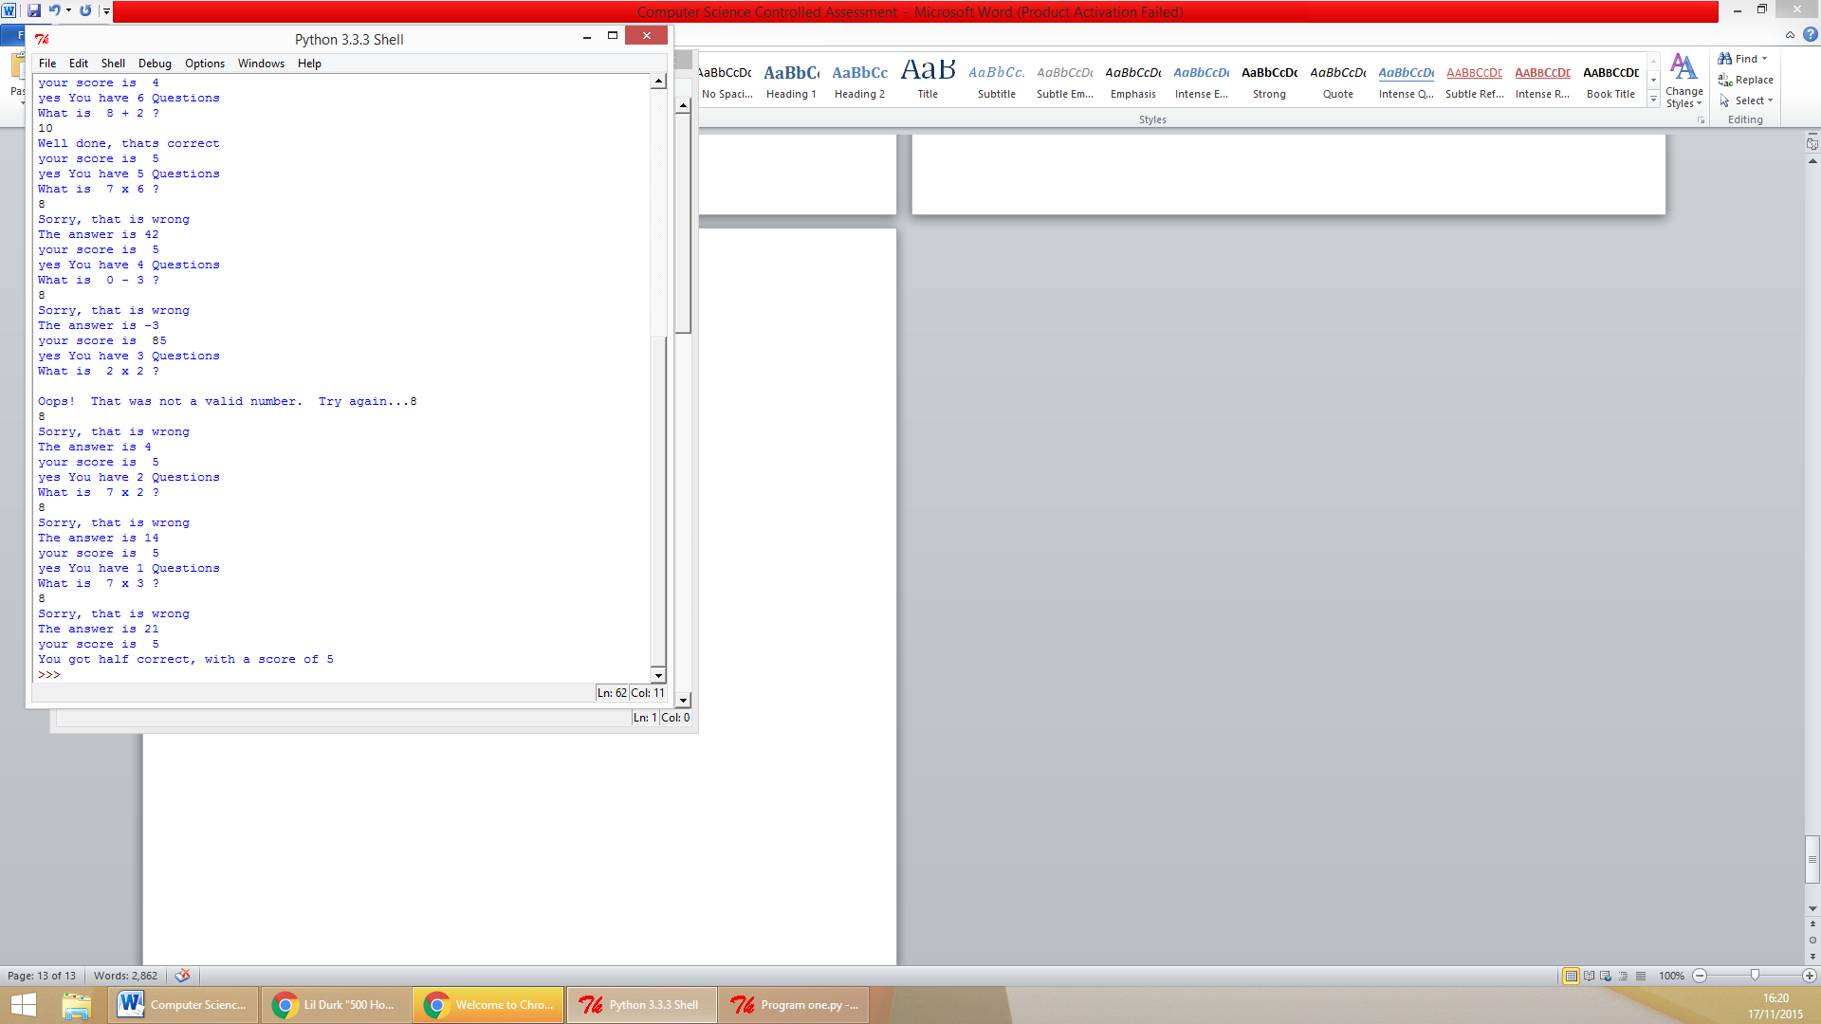  
The fourth test from my test plan I conducted on the program was the user is informed of their score at the end also after each question. The screenshots above depict the program to be meeting the test. They show that after several questions also at the end of the program the user is informed of their score. Because my program meets the requirements of this test the program can be marked as PASSED on this test plan.

Test Number Five:  
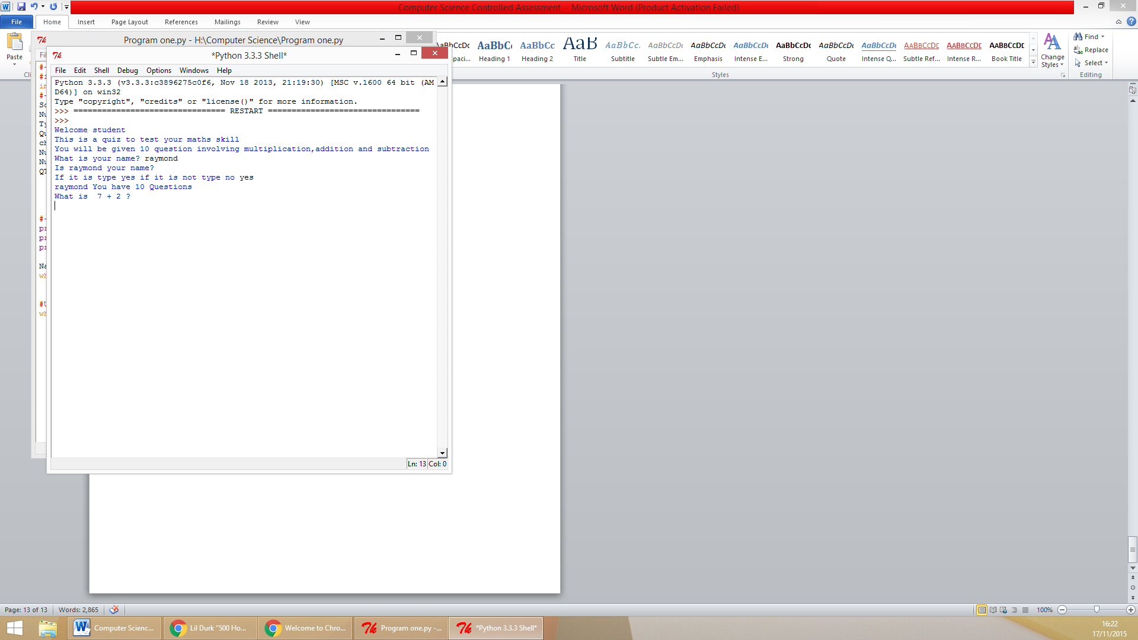

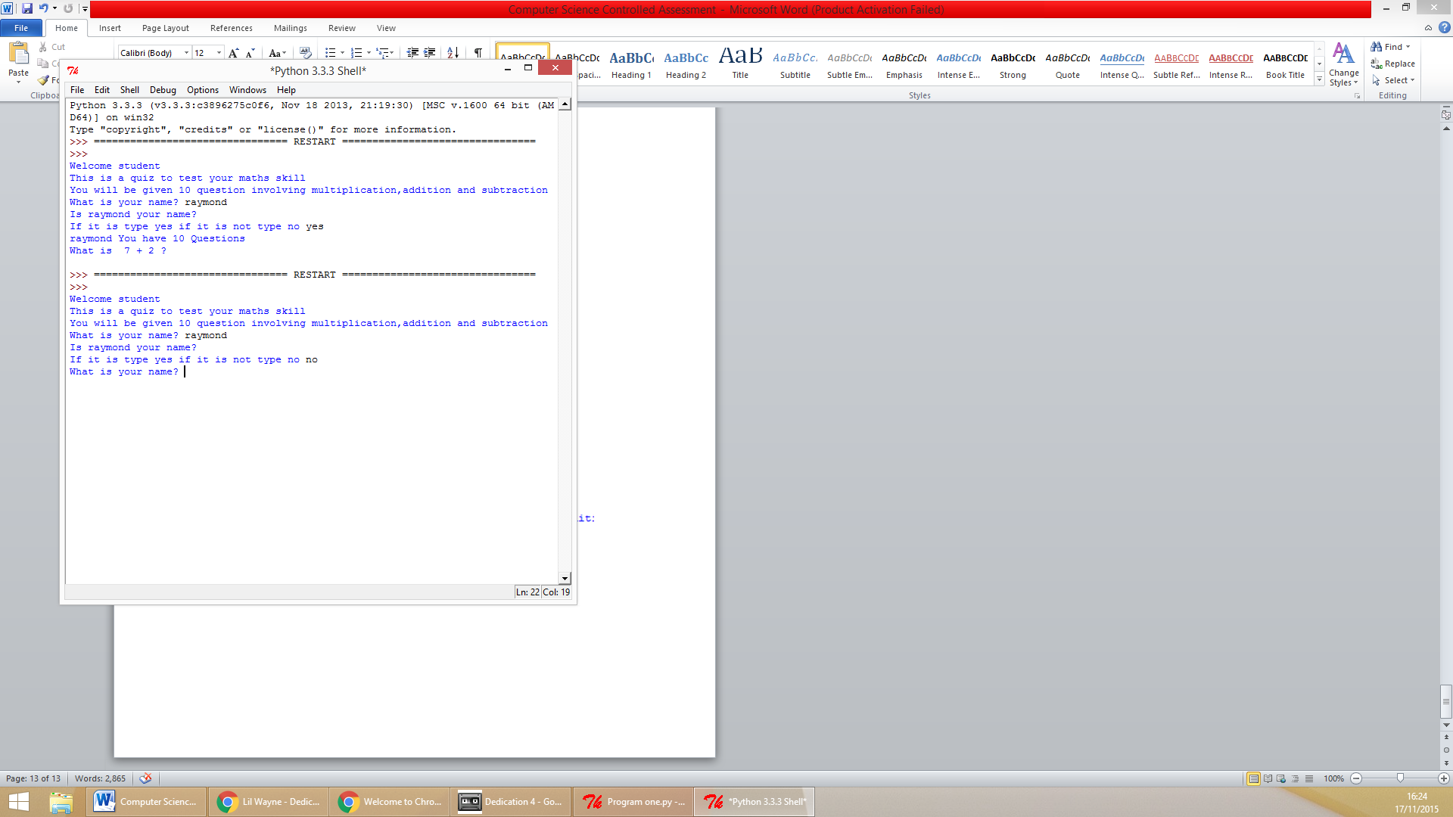  
As shown above the program PASSED the fifth test in the test plan. It passed it because when the user enters a valid name then they are asked to verify the name they have provided was correct. If it is the code runs to the lines after the “while” however if it is not they are prompted to enter a new one.

Test Number Six:

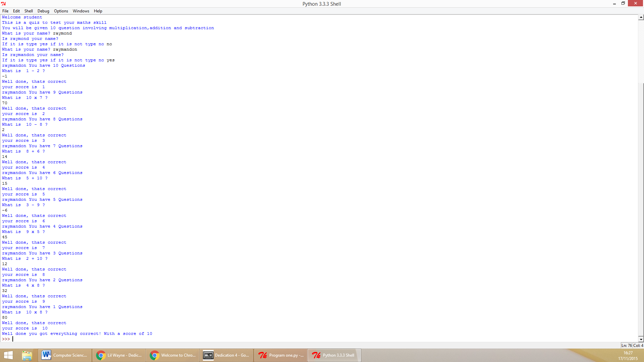

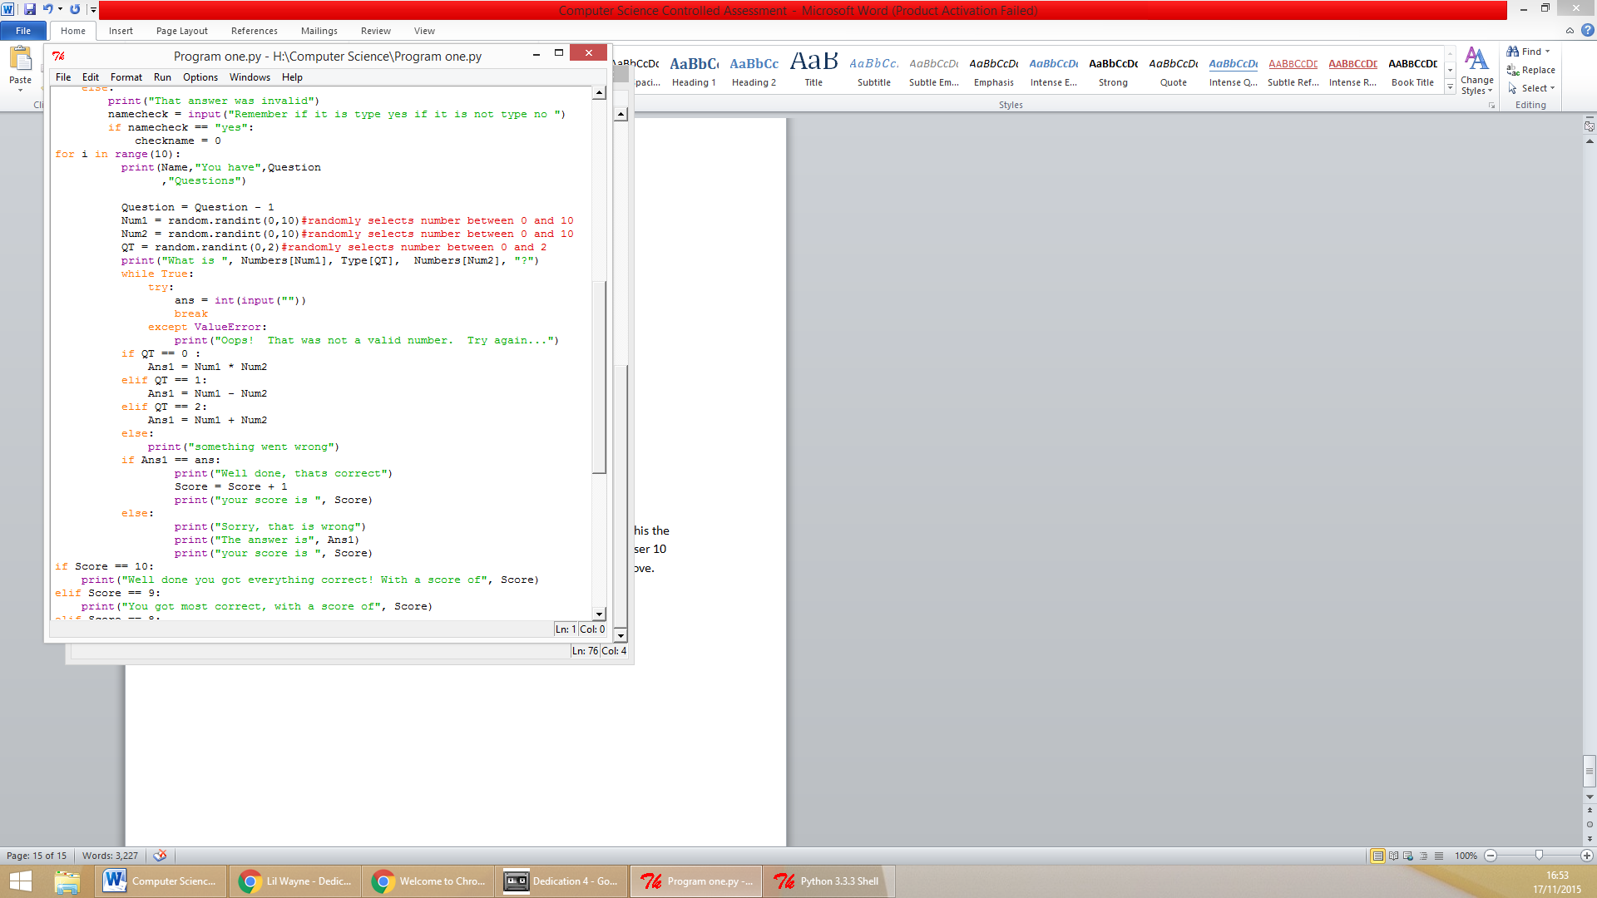

The screenshot above shows the program asking the user 10 questions due to this the program has a PASS on test plan six. To further prove the program will as the user 10 questions the used to make the program ask the user 10 questions is shown above. The code repeats the section in which the code as the user question 10 times meaning the user will always be asked ten questions.

**Evaluation**My program met all of the success criteria I set at the beginning for the code to be successful.

**The program asks the user of their name.** As tested in the test plan the user is prompted for their name at the beginning of the code.

**The user is not able to skip questions.** This is shown in the test plan “The user cannot skip questions”. When the user makes an attempt to skip a question they are prompted to answer question again.   
**It will ensure that a valid name is given.** This was met by the use of several python functions. It is shown in the test plan. When the user does not give a valid name they are made to enter a valid name also continued to me made to enter a valid name until they have done so.   
**The program will run fully without giving a logic, syntax or runtime error.** To ensure the program ran without error there was a development section in which I tested the program for errors to be returned by python when user utilizes program then amended these errors that I encountered.   
**The program will prompt the user to enter a number if the answer they provide to the question is not a number.** To meet this criterion I ran a test in the test plan called “The answer provided by the student to the questions must be a number”. The program passed this test plan, when the user never gave a numerical response they were prompted to enter one of which was numerical.  
 **The student will be informed whether their answer was correct at the end of each question in the code. At the end of the code the student score out of 10 will be displayed.**  Again to meet these success criteria’s I dedicated a section in my test plan to it. The name title of the test was “After each question and at the end of the program should print the users score”. This test enabled me to meet test the program met this success criteria.  
**If the student makes a typo in their name they can renter their name.** To verify the program ran according to the rules of this criterion I ran a section in the test plan by the name of “When user gives valid name they should be asked to verify name is correct” the program passed this test plan. This means the program also passed this success criterion. **The program will ask the student a total of ten questions.** As demonstrated in the test plan the code asks the student 10 questions using the *for* loop to repeat the section of the code where it asks the user the question ten times.

If I were to conduct the program again Instead of repeating sections of the code multiple times I would use defined functions. This will enable me to call the section later on in the code using the name of the function instead of repeating the line again in the code. This will result in shortened code length.   
To make the code to better I would employ several other features in my code. Instead of restricting the numbers that can be used to one to ten I would let the teacher be able to determine the range of numbers in which the student would be questioned. I would also prevent the code from selecting a question multiples during a quiz by storing the questions the user has been asked in several strings and using an *if* statement to make the code pick another question if it is the same as a previous one.

In my opinion the code was very successful; it met all the success criteria if I were to conduct another task similar to this aside from the improvements I stated above I create a program the same way as I did the one I made in this task.

**Task Two**

**Introduction**

The second task I will be attempting to complete is a code that enables the teacher to keep track of the scores that each member of her three classes achieve in the arithmetic program that I developed in task one. The code will need to save the scores of the students when they have finished the quiz. It will need to be able to save the students score in three different text documents depending on the class the student is in.

**Success criteria**

To ensure the program runs as expected according to the task there are several success criteria’s I will be setting for the code :

* The program will ask the user what class they are in.
* The program will be able to create three text files and will save the three text files in the same location the program is saved in.
* When the user has finished arithmetic quiz it will save their score corresponding to the class they are in and name on a text file.
* The program will run without giving an error
* If the user enters incorrect class they can re-enter correct class
* User has to enter valid class

**Algorithm**

Below is the algorithm from the previous task combined with the newly made edits to complete this task.

**Function SaveScore  
 Open "Class One.txt"For Append As Class_one  
 Open "Class Two.txt"For Append As Class_two  
 Open "Class Three.txt"For Append As Class_three  
 IF Class = 1  
 Write Class_one, “Name”  
 Write Class_three, “Score”  
 ELSE IF Class = 2  
 Write Class_one, “Name”  
 Write Class_two, “Score”  
 ELSE IF Class = 3  
 Write Class_one, “Name”  
 Write Class_three, “Score”  
ENDIF  
ENDfunction**

**Validate_Class = 1**

Numbers ["0","1","2","3","4","5","6","7","8","9","10"]   
Score 0   
Type ["x","-","+"]  
Question 10  
Num1 0  
Num20  
QT 0  
checkname 1

OUTPUT “Welcome student”

OUTPUT “This quiz will test your math skills”

OUTPUT “You will have 10 questions”

INPUT Name

WHILE checkname = 1  
 Output ”Is”, Name, “your name”  
 INPUT namecheck1  
 namecheck  namcheck1.LowerCase  
 IF namecheck = yes  
 checkname0  
 ELSE IF namecheck = no  
 INPUT Name   
 ELSE   
 OUTPUT “Invalid answer”  
 OUTPUT “If it is type yes if its not type no”  
 END IF  
END WHILE

**Output "There are three classes: 1, 2 and 3. What class are you in?(you can find out by asking your teacher.)"  
  
WHILE TRUE  
 TRY  
 INPUT Class  
 BREAK  
 EXCEPT ERROR  
 OUTPUT ”That is not a valid number”   
 END Try  
END WHILE**

**While Class < 3 or Class =< 0   
 Output "There are three classes: 1, 2 and 3. What class are you in?(you can find out by asking your teacher.)"  
 TRY  
 INPUT Class  
 BREAK  
 EXCEPT ERROR  
 OUTPUT ”That is not a valid class”   
 END Try  
ENDWHILE**

**WHILE Validate_Class = 1**

**Output ”Is”, Class, “your class”**

**INPUT Class_Check**

**Classcheck1** **Class_Check.LowerCase**

**IF Classcheck1 = yes**

**Validate_Class** **0**

**ELSE IF Classcheck1 = no  
 TRY  
 INPUT Class  
 BREAK  
 EXCEPT ERROR  
 OUTPUT ”That is not a valid number”   
 END Try  
 While Class < 3 or Class =< 0**

**Output "There are three classes: 1, 2 and 3. What class are you in?(you can find out by asking your teacher.)"**

**TRY**

**INPUT Class**

**BREAK**

**EXCEPT ERROR**

**OUTPUT ”That is not a valid class”**

**END Try**

**ENDWHILE**

**ELSE**

**OUTPUT “Invalid answer”**

**END IF**

**END WHILE**

FOR i FROM 1 TO 10  
 OUTPUT “You have”, Question, “Questions”  
 Question Question – 1  
 Num1 genRandomInt[0, 10]  
 Num2 genRandomInt[0, 10]  
 QT  genRandomInt[0, 2]  
 OUTPUT “What is”, Numbers[Num1], Type[QT], Numbers[Num2], “?”  
 WHILE TRUE  
 TRY  
 INPUT ans  
 BREAK  
 EXCEPT ERROR  
 OUTPUT ”Not a valid answer”   
 END Try  
 END WHILE  
 IF QT = 0   
 Ans1  Num1 * Num2  
 ELSE IF QT = 1  
 Ans1  Num1 – Num2  
 ELSE IF QT = 2  
 Ans1  Num1 + Num2  
 END IF   
 IF Ans1 = ans  
 OUTPUT “Well done”  
 Score Score + 1   
 OUTPUT “Your Score is”, Score  
 ELSE   
 OUTPUT “That’s wrong”  
 OUTPUT ”The answer is”, Ans1  
 OUTPUT “Your Score is”, Score  
 END IF

END FOR

IF Score = 10  
 OUTPUT "Well done you got everything correct! With a score of", Score  
ELSE IF Score = 9  
 OUTPUT "You got most correct, with a score of", Score  
ELSE IF Score = 8  
 OUTPUT "You got most correct, with a score of", Score  
ELSE IF Score = 7  
 OUTPUT "You got most correct, with a score of", Score  
ELSE IF Score = 6  
 OUTPUT "You got most correct, with a score of", Score  
ELSE IF Score = 5  
 OUTPUT "You got half correct, with a score of", Score  
ELSE IF Score = 4  
 OUTPUT "You got some correct, with a score of", Score   
ELSE IF Score = 3  
 OUTPUT "You got some correct, with a score of", Score  
ELSE IF Score = 2  
 OUTPUT "You got some correct, with a score of", Score  
ELSE IF Score = 1  
 OUTPUT "You got some correct, with a score of", Score  
ELSE IF Score = 0  
 OUTPUT "Unlucky got none correct, with a score of", Score  
ENDIF

**Call: SaveScore**

**Justification of approach**

Like the previous task, in this section I will be justifying the approaches I am making towards the code. I will be using the append (“a”) function when writing the code instead of the writing (“w”)because it enables the program to create a new file if one does not already exist. If one already exists it enables me to edit the contents of the program without erasing what the document already holds.

I will use try and except when the user enters the class they are in because it prevents the program from getting a runtime error if the user does not enter a number in response to when they are asked what class they are in. Try and except also enables me to ensure that the user can only enters a when they are asked the question.

I be using a while loop. A while loop enables me to run a section of the code in which is within its indent continuously until a condition changes. The reason I am using a while loop over any other loop because I need it to keep running the section of a code which asks the user what class they are in until they enter a correct class.

**Variables**

|  |  |  |
| --- | --- | --- |
| **Name of the variable** | **The type of data the variable is** | **What I will use the variable for** |
| Class_one | String | This variable will be used to store an append able version of the text file for class one |
| Class_two | String | This variable will be used to store an append able version of the text file for class two |
| Class_three | String | This variable will be used to store an append able version of the text file for class three |
| Class | Integer | This variable will store the numerical response given when the user is asked their score |
| Validate_Class | integer | This variable will store the value 1 or 0, it will be used to ensure the while loop is still running or to stop it if the value of the variable is changed from 1. |
| Class_Check | String | This will save the response given to by the user regarding whether the class they provided was correct. |
| Classcheck1 | Sting | This will save a lowercase version to the response given to the variable Class_Check. |
| Name | Refer to task one | Refer to task one |
| Score | Refer to task one | Refer to task one |

**Validation**

Throughout the code I will be validating parts; this will enable me to meet my success criteria. Below they are listed.

1. The response given to by the user when they are asked what class they are in must be a number
2. The response given to by the user when they are asked what class they are in must match one of the three classes their teacher teaches.

**Test Plan**

|  |  |  |  |
| --- | --- | --- | --- |
| No | Test | Test Data | Expected outcome |
| 1 | Test program asks user what class they are in | **Normal:** Run code. | **Normal**: When program is run the user is asked what class they are a part of. |
| 2 | Test the program saves the user’s name and score on a text file according to their class. | **Normal:** Complete quiz then make sure saved data matches students score printed at end of quiz | **Normal:** Word file matches score printed at end also word file must match class user entered. |
| 3 | Test the program saves text files in same file location program is in | **Normal:** Check location of files python saved them in. | **Normal:** Location of the files are saved in are same as program. |
| 4 | Test when user gives valid class they can enter another if they gave class they are not in. | **Normal: “**No”, “nO”, “NO”, “no”  **Boundary: “Yes” “yes” “YES” “yEs” “yeS” “YEs” “YeS” “yES”**  **Erroneous:**  Any other form of data e.g. “gdgiysds” | **Normal:** Prompt student to enter new class.  **Boundary:** Continue to next section of code.  **Erroneous:** Ask user to re-enter response until valid response is given. |
| 5 | Test user can only enter a class their teacher teaches. | **Normal:** “1” , “2”, “3”  **Erroneous:** Any other response | **Normal:** Continue to next section of code.  **Erroneous:** Prompt user to enter correct class until they do so. |
|  |  |  |  |

**Development**

In my program I used several comments to show step by step what each section of the code is doing. I began the edits to the arithmetic quiz on line 6, I defined a function and named it “SaveScore()”. Then on lines 7 -9 the code creates three text files if they don’t already exist called “Class_one”, “Class_two” and “Class_three”. I opened them in append mode. This entails that the contents of the code will be edited without it destroying the previously saved data within it. From lines 10-26 the code uses “if” and “elif” functions to check the class the user entered they are in. Then depending on the class the student is a part of the code saves the users name also score on one of the three text files created at the beginning of the code. Only one variable is added to the variables list. This variable is called “Validate_Class” and is assigned to the value of “1” it is shown on line 37 of the code. On lines 44 – 49 of the code the user is prompted to enter the class they are in. When they enter their class the code checks to make sure that they entered a number. If the user does not enter a number then they are prompted to enter their class again until they enter a numerical response. From lines 52 – 57 the code uses a while loop to check whether the user entered a class that their teacher teaches. If they did not enter a class their teacher teaches they are then prompted to enter a different number until they do. When the user enters a valid class the code runs to the next section, lines 59 – 80. In this block of the code the user is asked to confirm the class they have entered is correct if the user responds “yes” then the code runs on to the introductory phase of the arithmetic section of the code. If the user responds “no” then they are prompted to enter the class they are a part of. If the user enters a response that is neither “yes” or “no” they are told the response they have entered to the question is invalid and are made to answer question again. The last amendmen that was made to the code was on the final line, 165, the function “SaveScore()” is called so the score the user received when they completed the arithmetic quiz can be saved to a text file corresponding to which class they are a part of.

Here is my final code

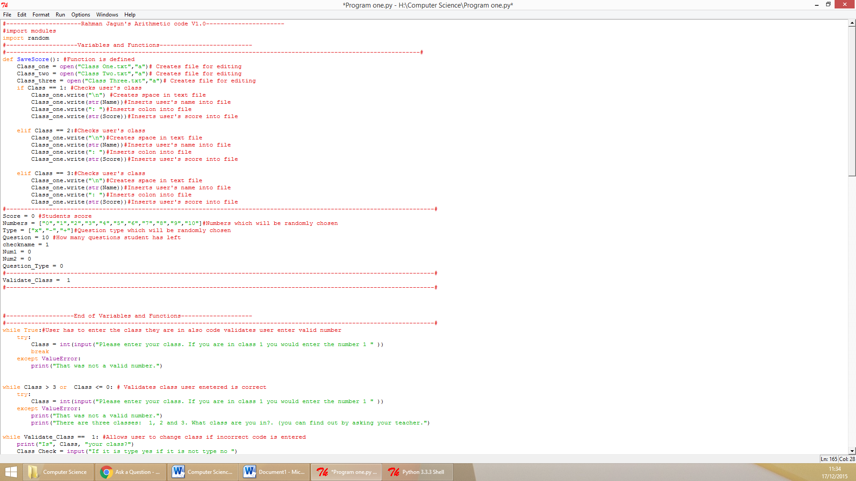

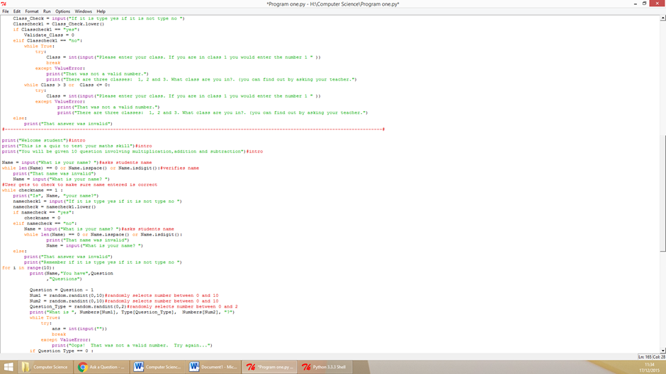

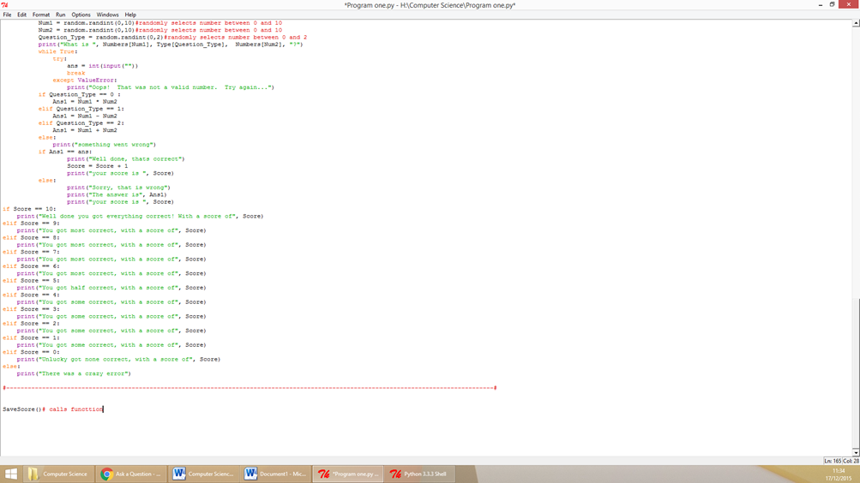

**Testing during development**

I ran several test during the development of the program below are the errors I encountered and how I managed to solve them.

Syntax error

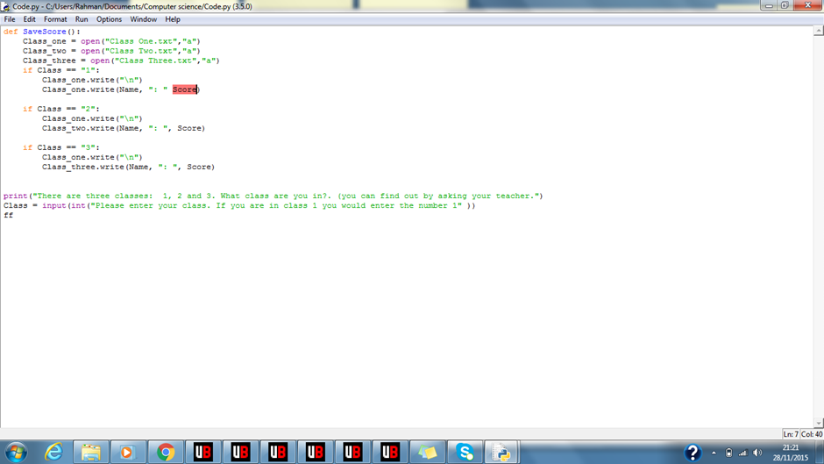

Like the previous task the first error I received during the development of the program was a syntax error. The variable “Score” is highlighted this entails that something is missing before it. Due to this I searched for something that was missing within this line of code and I found out it was a comma missing in between the speech marks and the variable to fix the program I simply added the missing comma in as shown below.  
 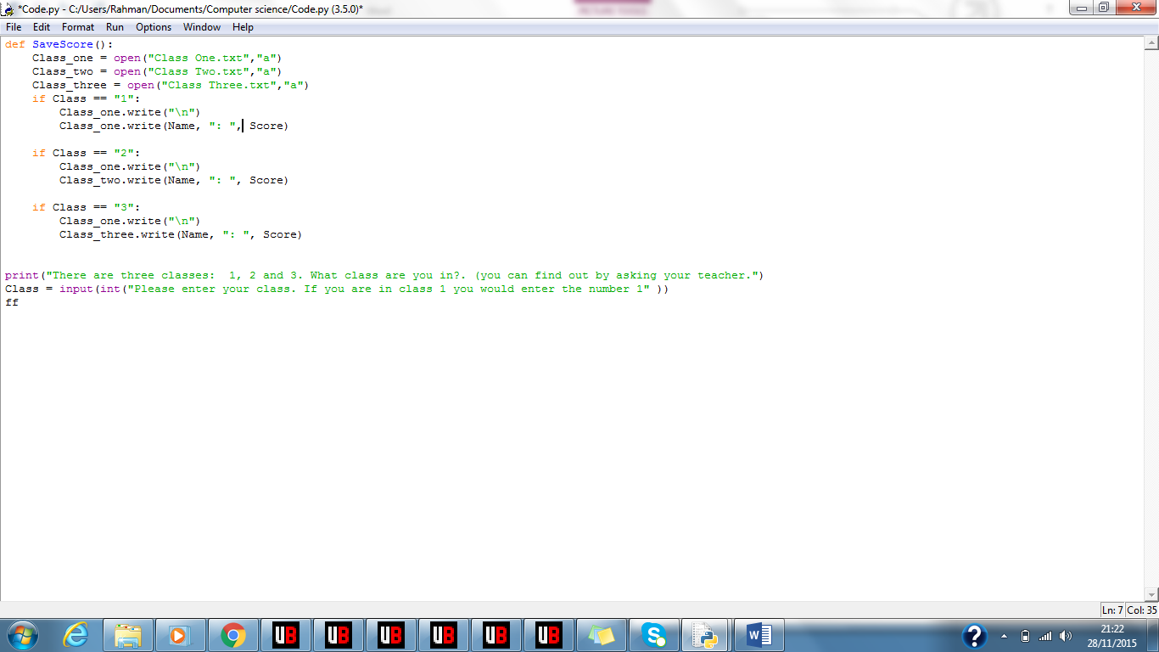

Runtime Error

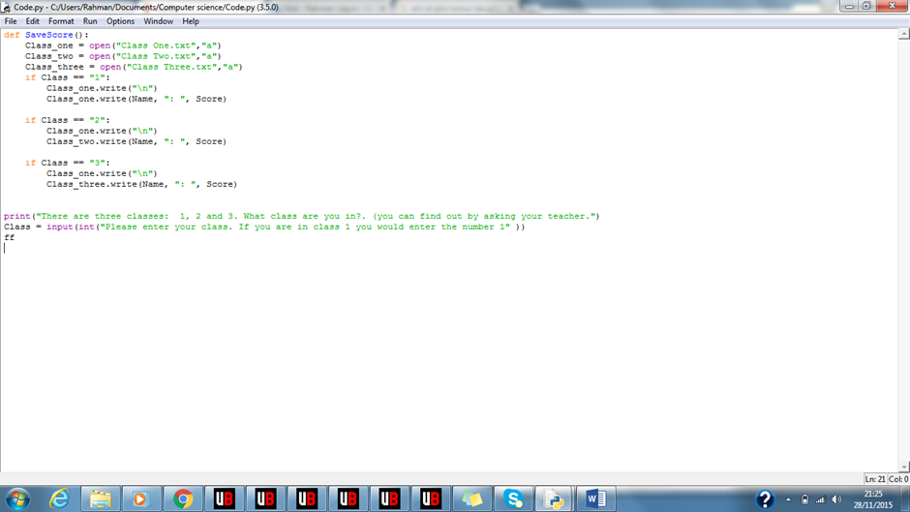

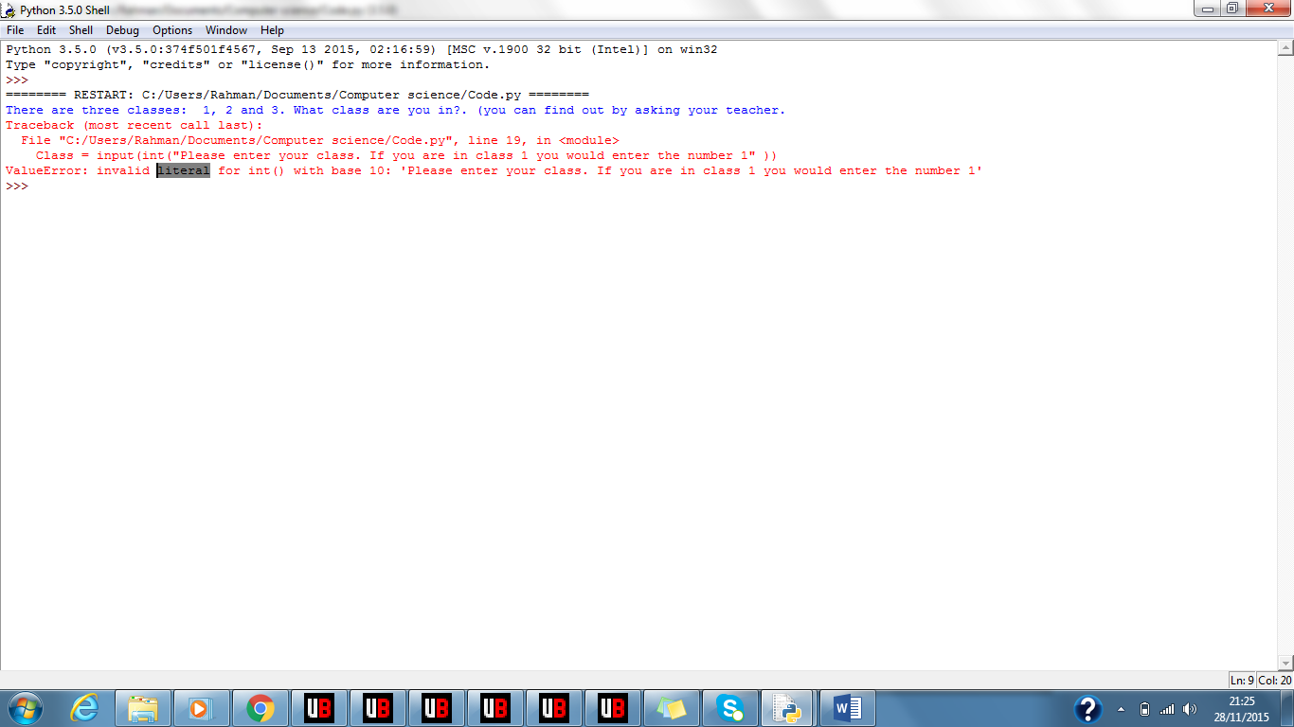  
The second error I got was a runtime error. This happened when the program attempted to run the line of code shown in the first picture. The reason behind this error was because I wrote “input(int” instead of “int(input” this caused python to crash because python is not able to recognise an input which the “int” is put after the “input”. To fix this I swapped the “int” also the “input” around and the code was able to run to the next line. The remodelled code is shown below.

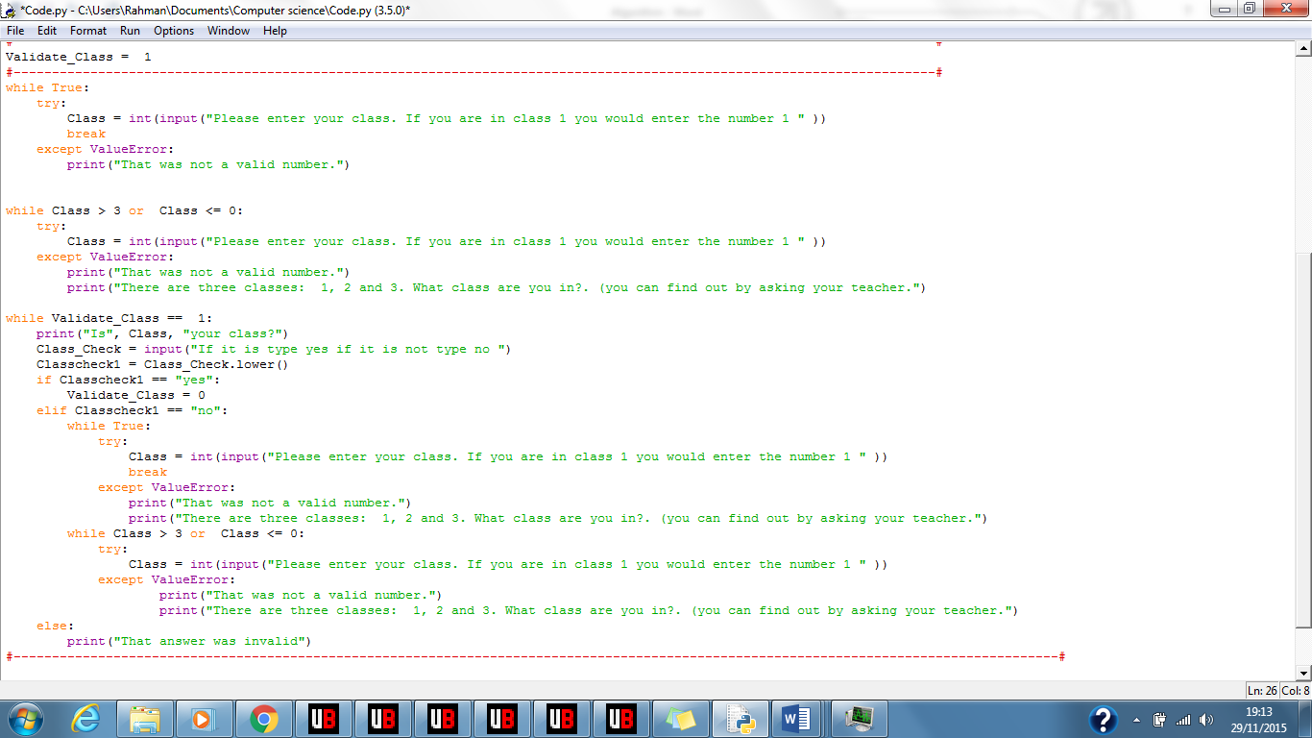

Runtime Error  
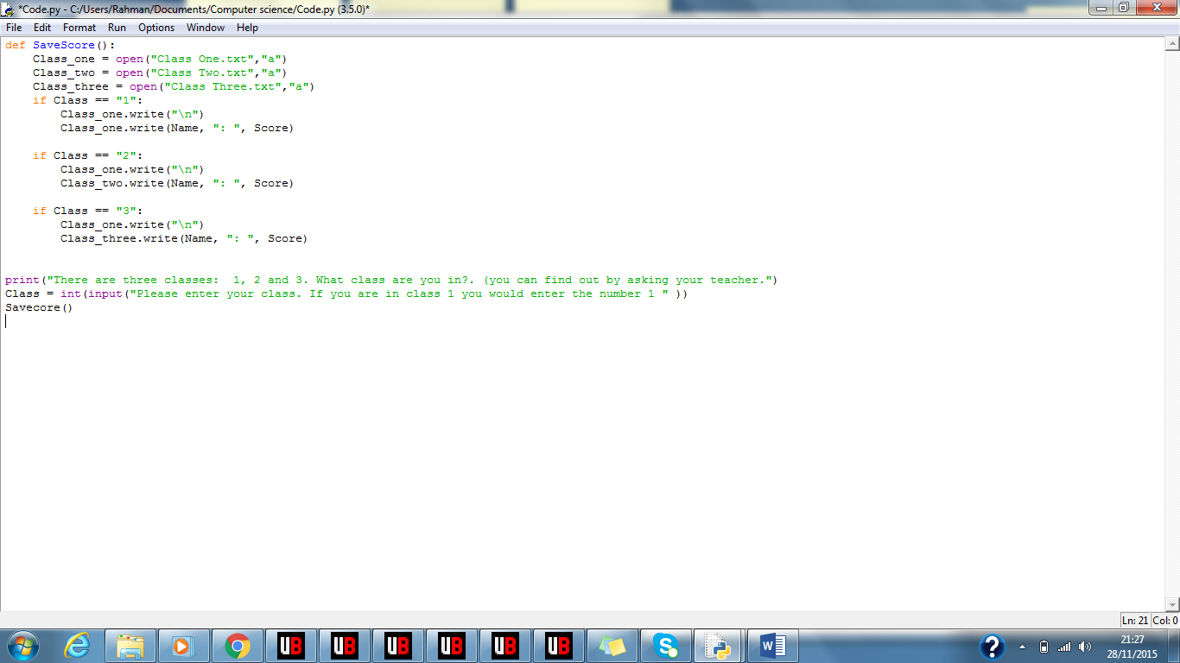

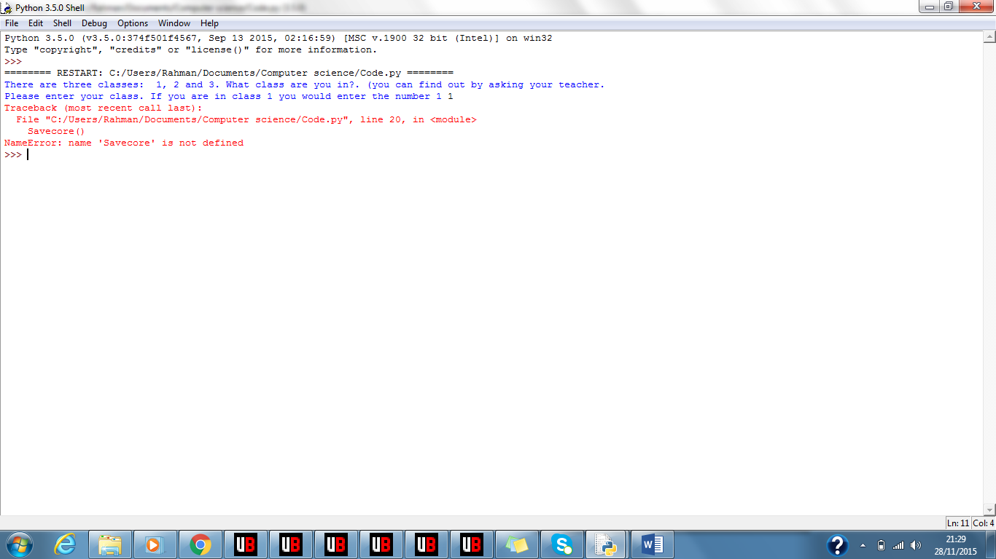  
The third error I received was another runtime that happened when the code attempted to call the function. The error diagnostics quoted “Savecore is not defined” this means that there is no function called “Savecore”. To figure out how to resolve this error I compared what I wrote to call it and what I defined the function the I came to a realisation that when I was calling the function I misspelt it. I wrote “Savecore()” instead of writing “SaveScore()”. So to amend the code I changed “Savecore()” into “SaveScore()”. After that the code was able to run without displaying the same error.  
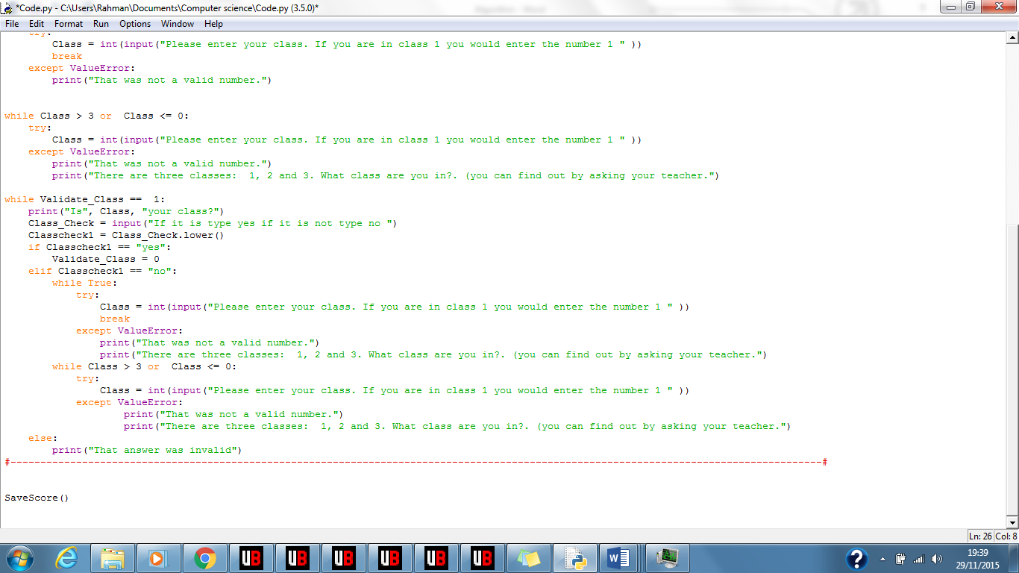

Syntax error  
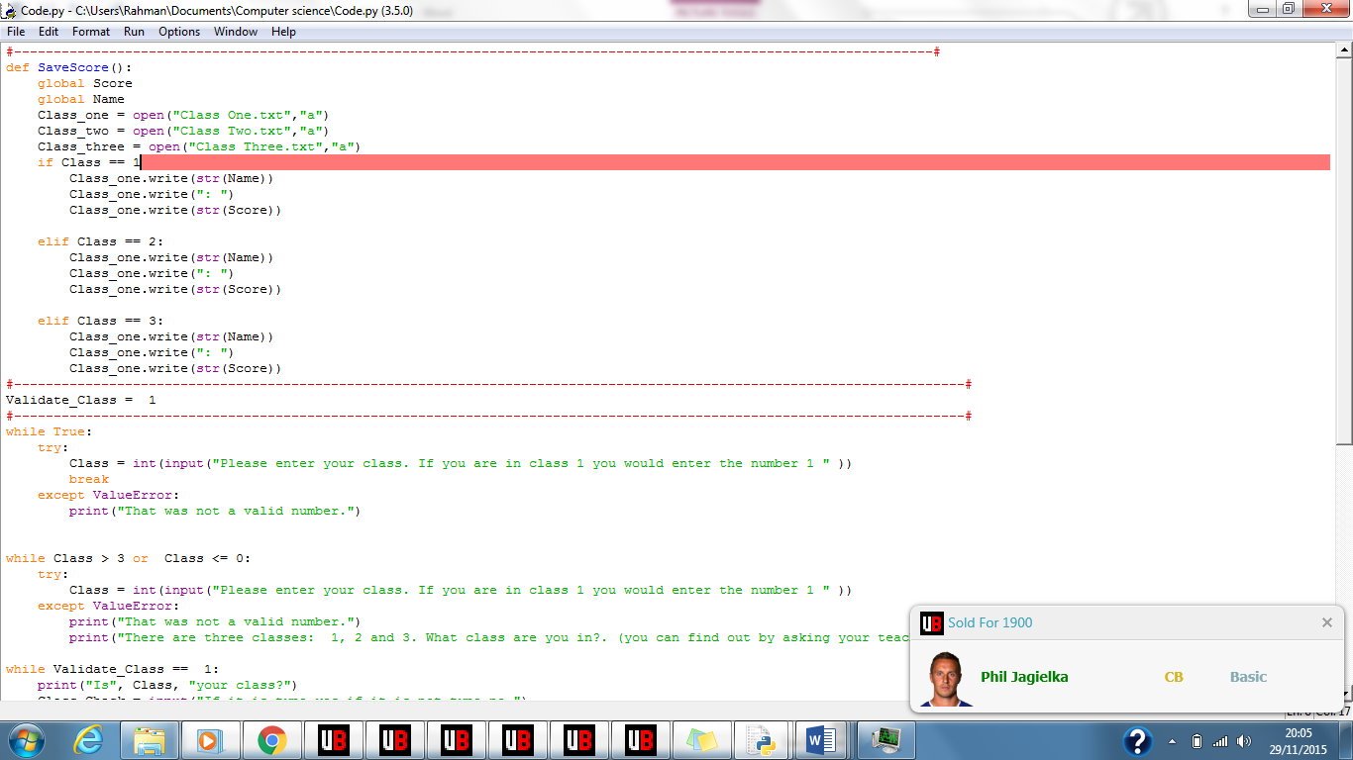  
  
The fourth error I received while developing the program was a syntax error. A syntax error means there is something missing within the code which is preventing it from continuing to the next line. To identify the problem with the code I searched on the line which is highlighted in red for something missing. Then I realised I was missing a colon at the end of the “1” so I inserted the missing colon which is shown below then the program was able to run on to the next line.  
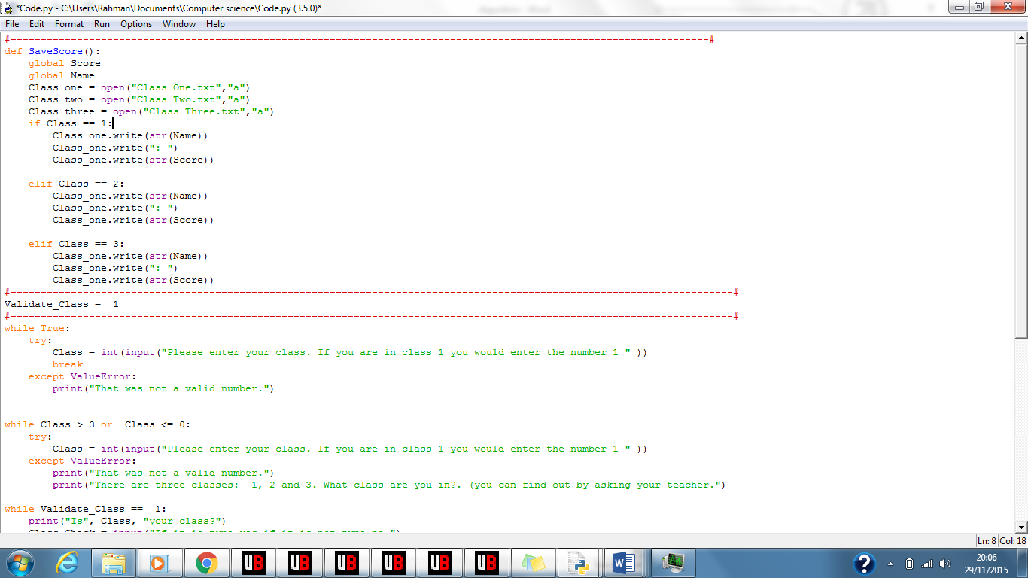

Logic error

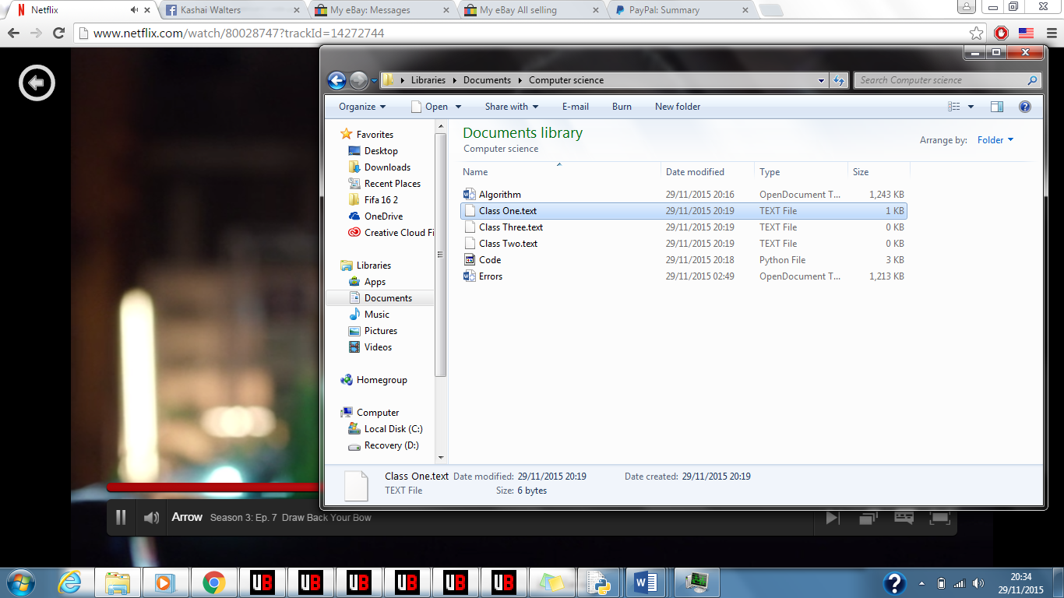

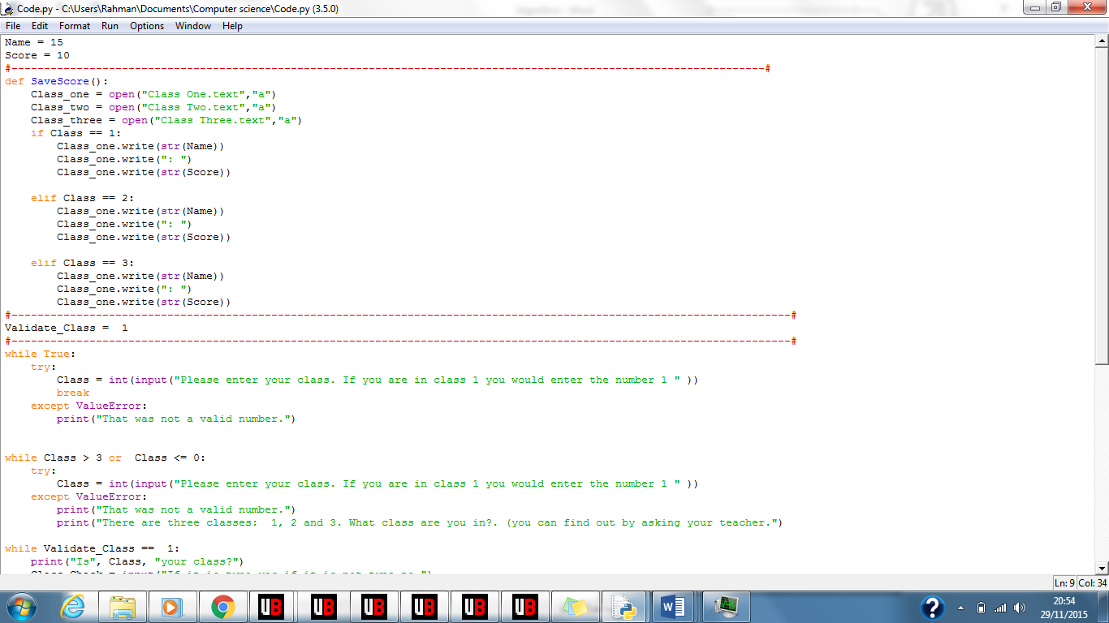

When I ran the almost complete code and tested it to see if everything was fully functional I found that the program saved the files as TEXT file instead of a Text document as shown in the first image. I figured that the problem must be with the code in which the text files were created so after searching I realised that instead of writing “Class… .txt” I wrote “Class… .text”. I then corrected the mistake I made (as presented below) and when I ran the code it saved the files in the correct type of file format also displayed below.  
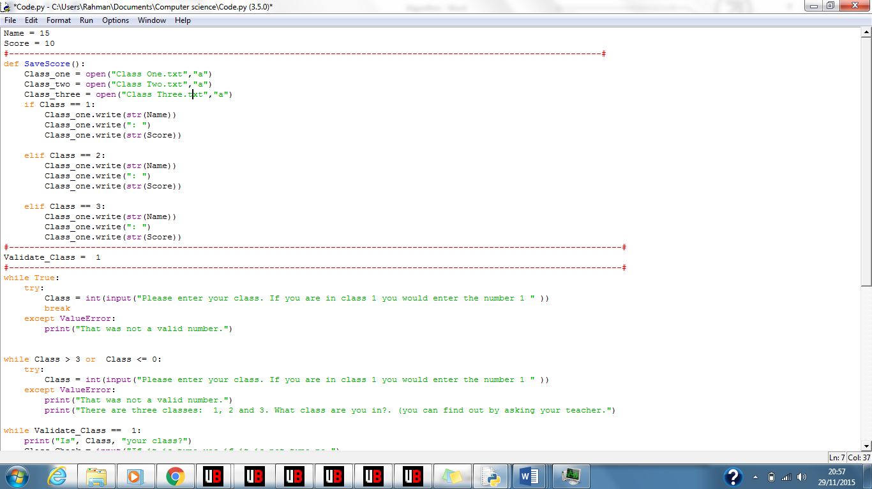

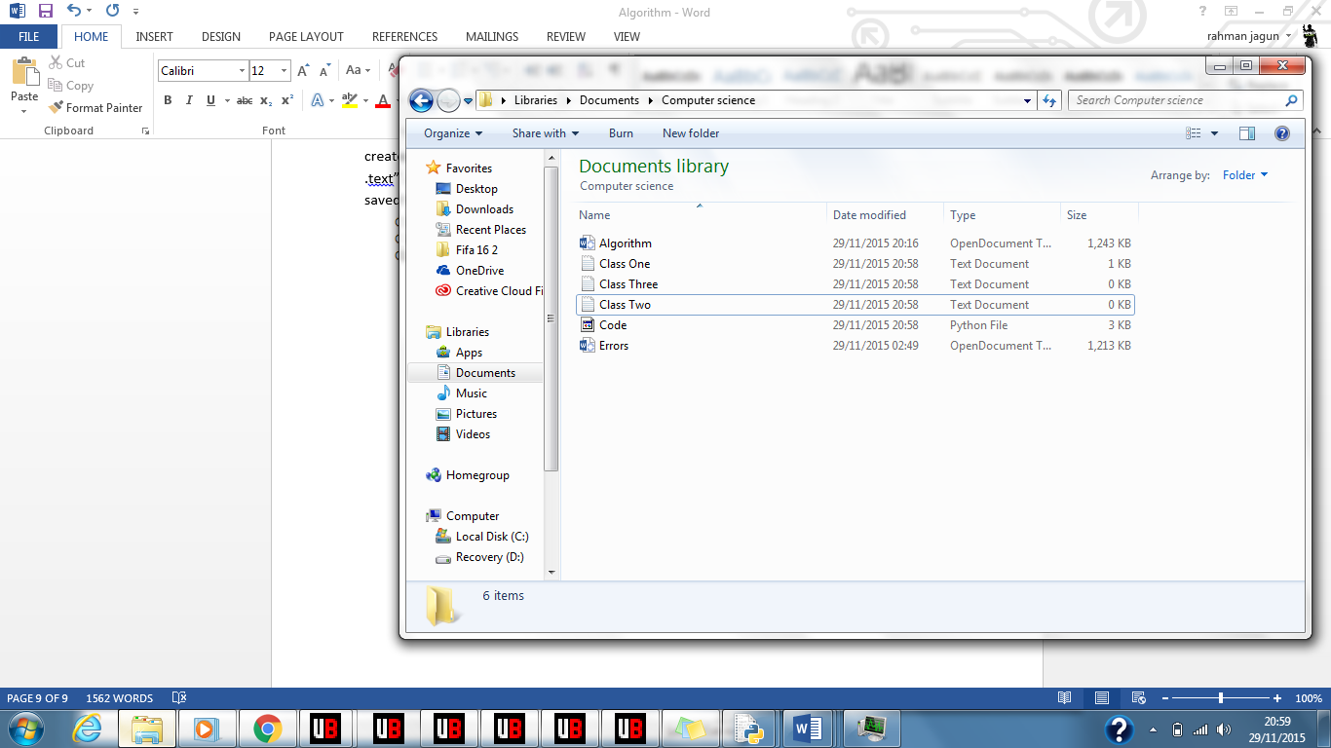

**Testing**To ensure my success criteria’s were met I made several other tests on the program I created below is the test plan.

|  |  |  |  |
| --- | --- | --- | --- |
| No | Test | Test Data | Expected outcome |
| 1 | Test program asks user what class they are in | **Normal:** Run code. | **Normal**: When program is run the user is asked what class they are a part of. |
| 2 | Test the program saves the user’s name and score on a text file according to their class. | **Normal:** Complete quiz then make sure saved data matches students score printed at end of quiz | **Normal:** Word file contents matches score printed at end also word file name must match class user entered. |
| 3 | Test the program saves text files in same file location program is in | **Normal:** Check location of files python saved them in. | **Normal:** Location of the files are saved in are same as program. |
| 4 | Test when user gives valid class they can enter another if they gave class they are not in. | **Normal: “**No”, “nO”, “NO”, “no”  **Boundary: “Yes” “yes” “YES” “yEs” “yeS” “YEs” “YeS” “yES”**  **Erroneous:**  Any other form of data e.g. “gdgiysds” | **Normal:** Prompt student to enter new class.  **Boundary:** Continue to next section of code.  **Erroneous:** Ask user to re-enter response until valid response is given. |
| 5 | Test user can only enter a class their teacher teaches. | **Normal:** “1” , “2”, “3”  **Erroneous:** Any other response | **Normal:** Continue to next section of code.  **Erroneous:** Prompt user to enter correct class until they do so. |
|  |  |  |  |

Test Number One:



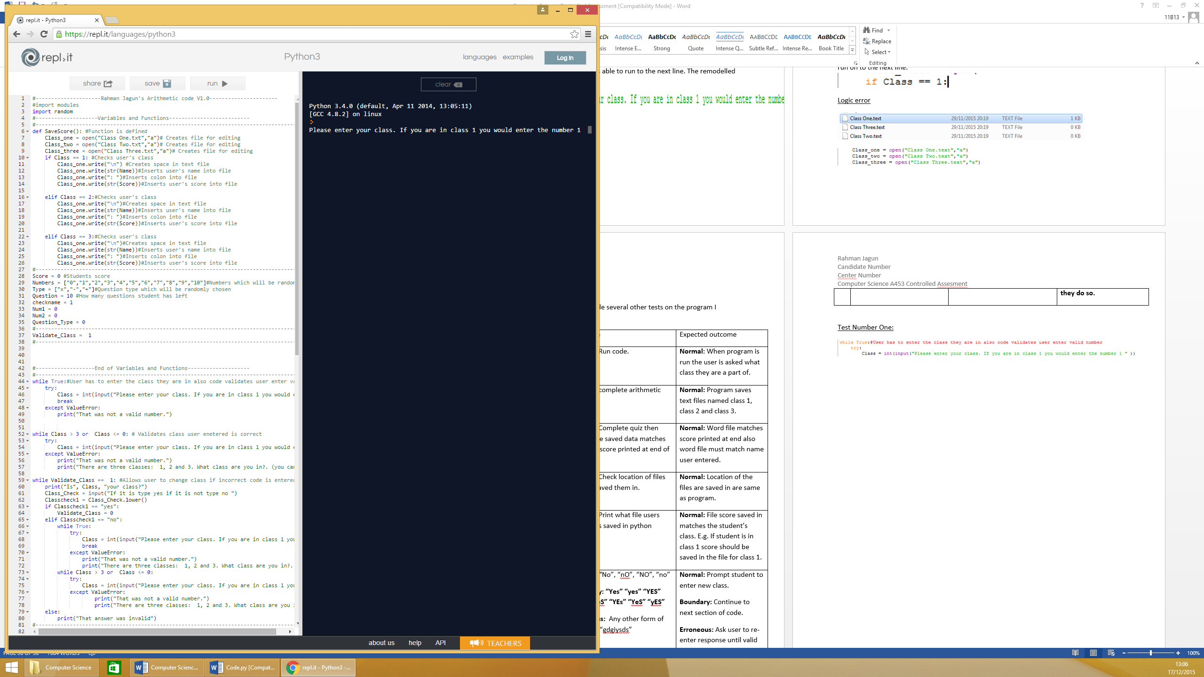

Above the screenshots show what happens when user runs the program. As shown in the second screenshot when the user runs the program they are prompted to enter the class they are in. The first screenshot shows the line of code that ensures the code asks the user what class they are in. The code has **PASSED** this test plan.

Test Number Two:

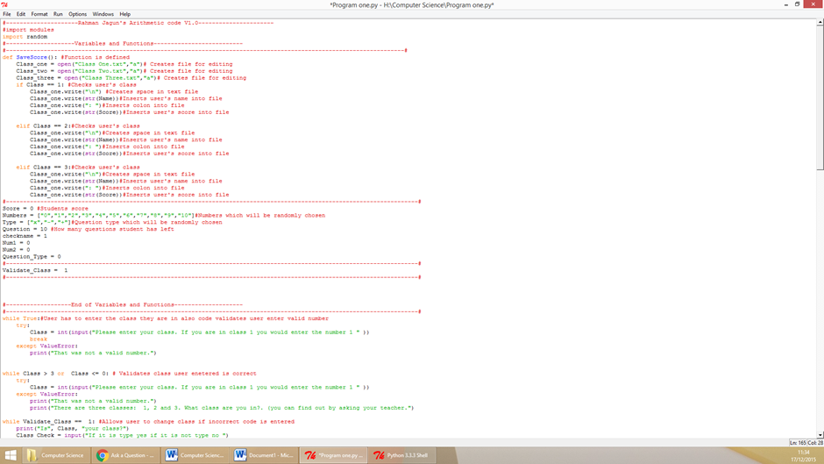

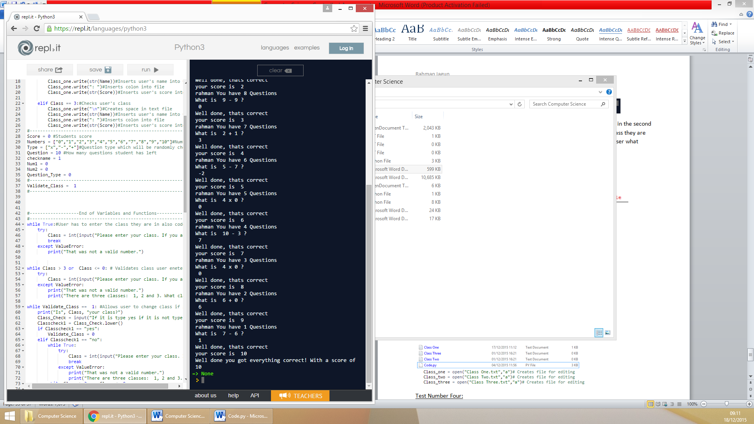

  


Above the screenshots show the program PASSED this test. The fourth screenshot shows the class the user entered. The third screenshot shows what is saved on the text file also the text file name (at the top). The second screenshot displays the score the user received. As the score saved on the text file matches the score the user received on the quiz also the file users score is saved in matches their class the program passed this test. The first screenshot shows the code used to ensure the score user received matches that of the test plan.

Test Number Three:

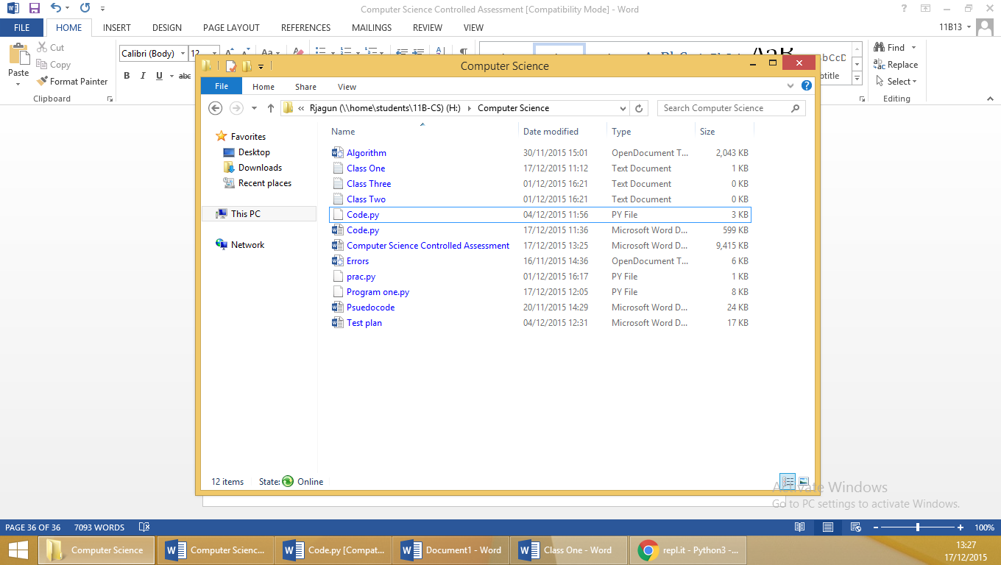  
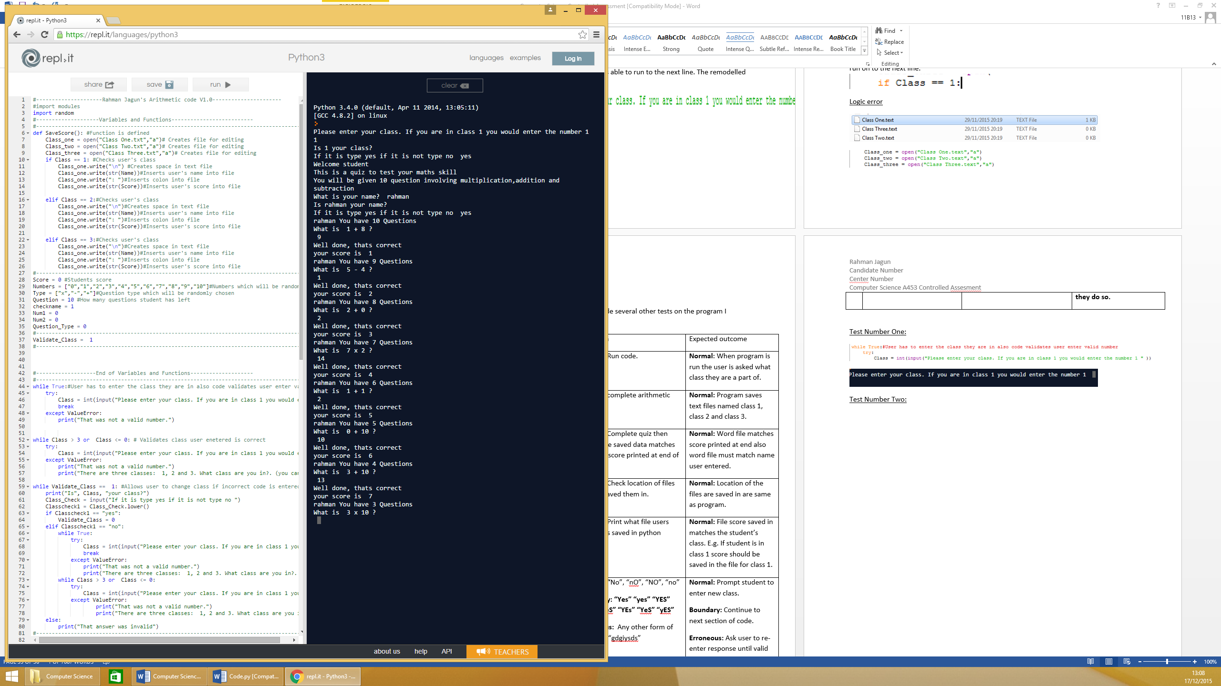

The program also PASSED this test plan. The screenshots above prove this. The first screenshot shows where the three text files are saved; they are all saved in the same location as the program. The screenshot below shows the section of code that ensured this test plan was saved.

Test Number Four:

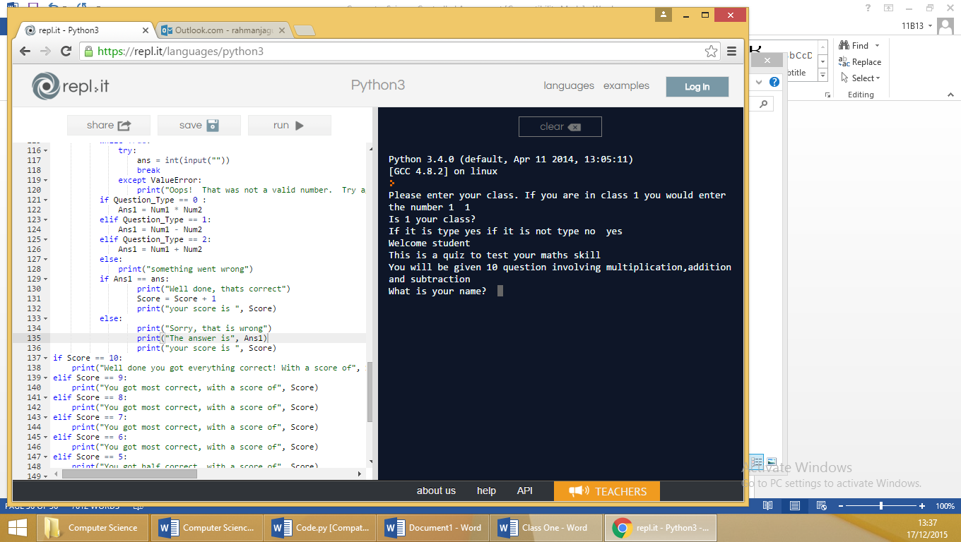

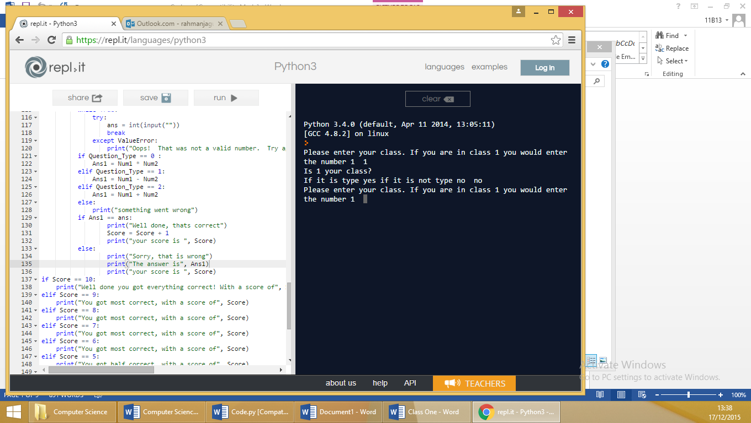  
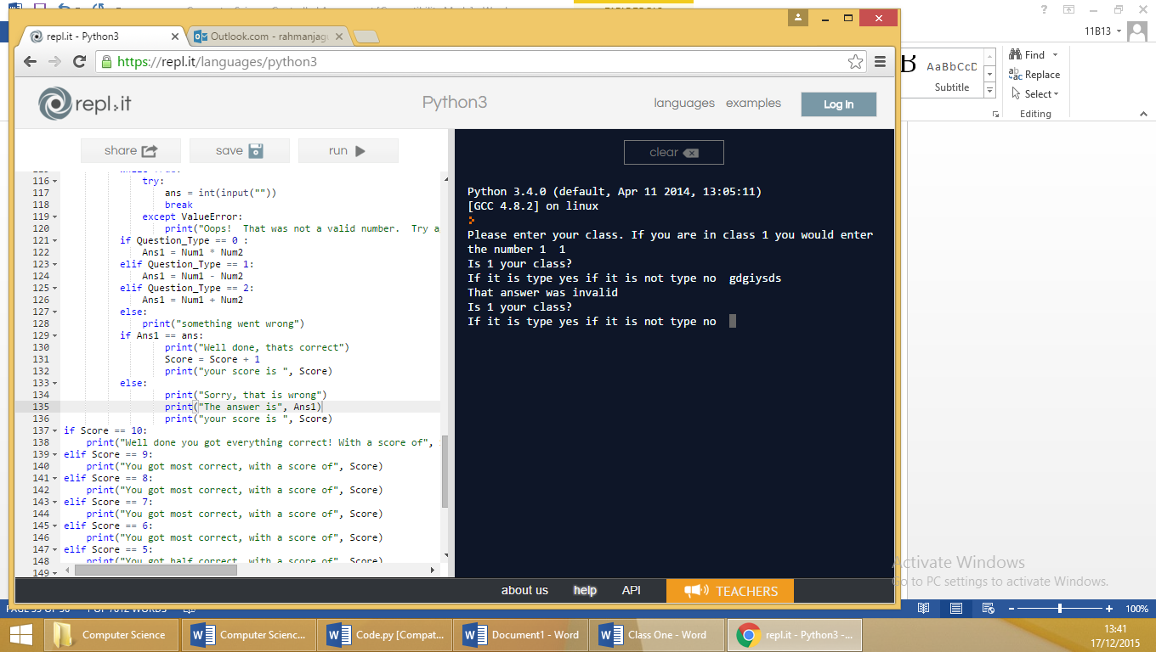

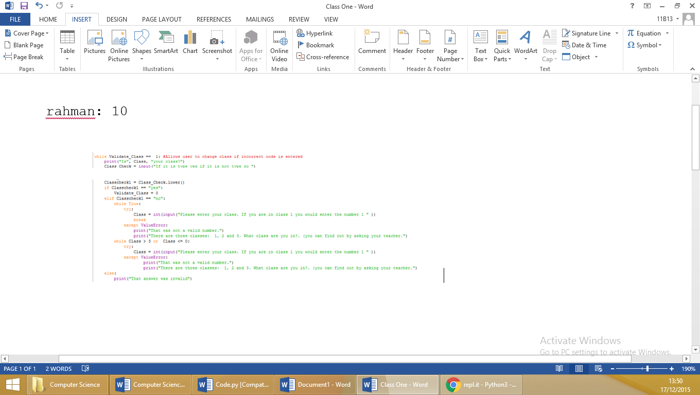

Above shows what happens when the user enters a valid class, they are asked to confirm the class they entered is correct. The first screenshot shows if they say yes then the program runs to the next section. The second screenshot shows if the user responds no they are prompted to enter a new class. The third screenshot shows if the user gives an invalid response they are asked the question again. Because the program runs as expected when instance of boundary, normal and erroneous data is entered the code PASSED this test. The last screenshot display the section of code that makes this happen.

Test Number Five:

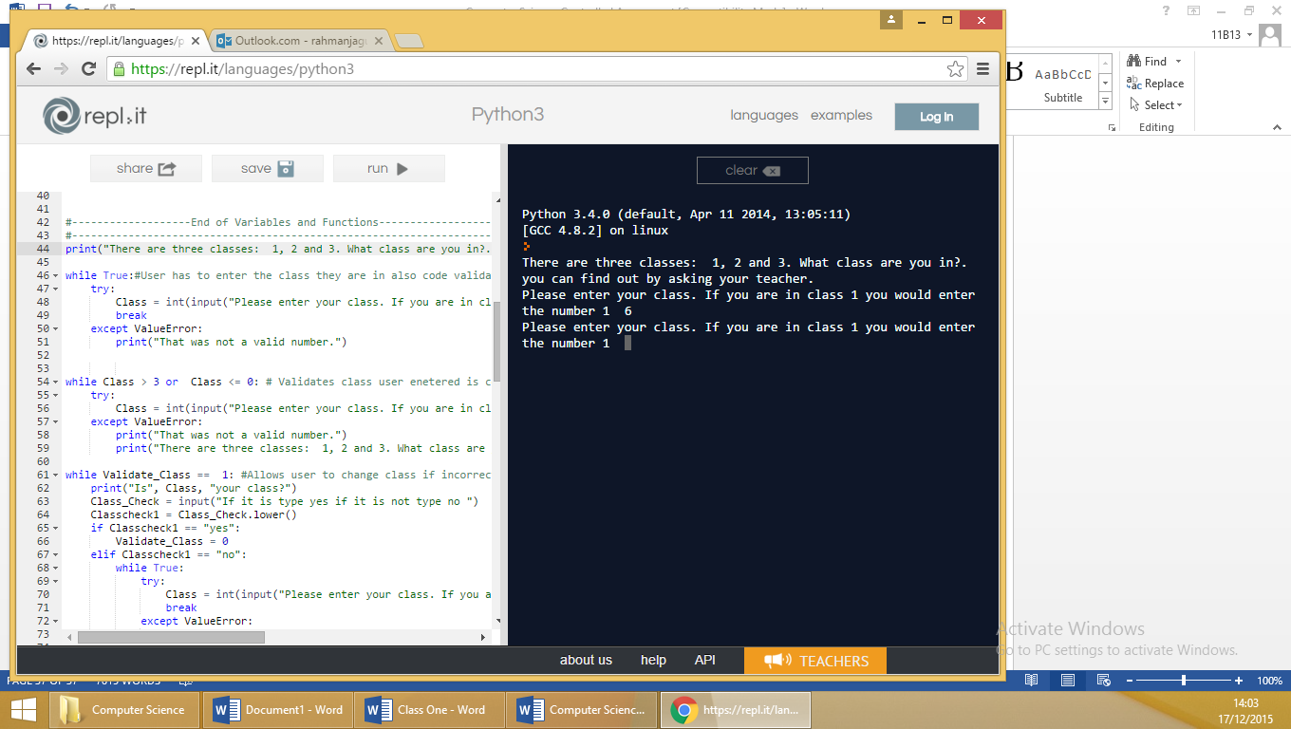

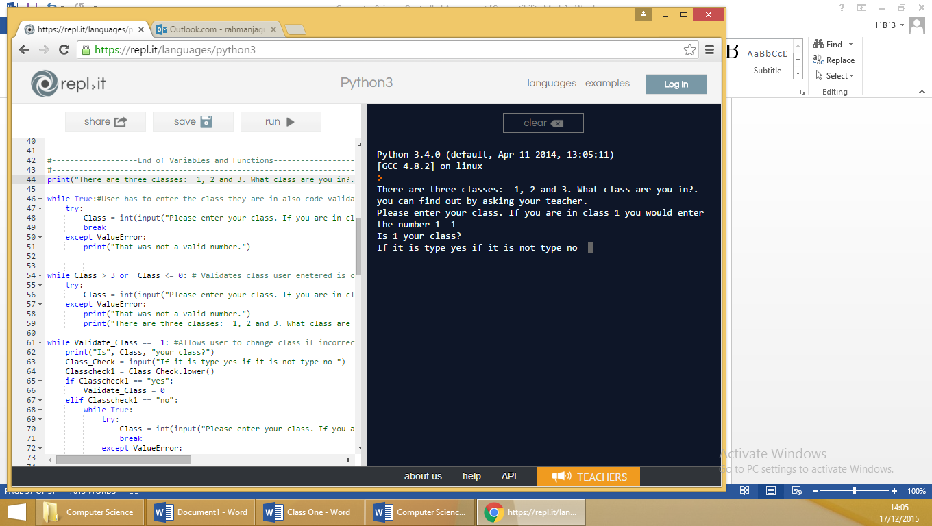



The first screenshot shows what happens when the user enters erroneous data; they are asked the question again. When the user enters normal data the program runs to the next section. The results that are given when user enters normal data and erroneous data match the expected outcome of this test this entails that this program PASSED this test plan.

**Evaluation**My code successfully met all the success criteria.

**The program will ask the user what class they are in.** The first test plan was dedicated to ensure that the program met this success criterion. When the user runs the program the first thing that comes is a question asking them what class are they a part of.

**The program will be able to create three text files and will save the three text files in. the same location the program is saved in.**  This criterion was met and was shown in the test plan called “Test the program saves text files in same file location program is in”. The program uses the “open” function to open three text files and saves it in the same folder as that of the arithmetic quiz program.

**When the user has finished arithmetic quiz it will save their score corresponding to the class they are in and name on a text file.** The code asks the user what class they are in and if they are in class one then their arithmetic quiz details will be saved in the text file for class one. If they are in class two then their arithmetic quiz details will be saved in the text file for class two. If they are in class three then their arithmetic quiz details will be saved in the text file for class three. This is shown in test plan number two.

**The program will run without giving an error.** To ensure this success criteria were met, I ran a section in the project called the “testing during development”. This section displayed any errors I received while developing the code also how I managed to fix them. When I ran the final code there were no other errors. This entails that this success criterion was met.

**If the user enters incorrect class they can re-enter correct class.** The program asks the user whether the class they entered is correct. If it is not then they are prompted to enter a new class. This is shown in test plan four.

**User has to enter valid class.** The code uses a while loop to ensure that this test plan is met. It loops the section of the code in which the user is asked what class they are in until they enter a class that their teacher teaches. This is depicted in test plan number five

If I were to create the code I will use another python function to enable the teacher to paste a list of all their student’s names into the code and what class they are in then the code will just match up the students name with the one the student name list the teacher has already inserted into the code. This will ensure that the students’ details are definitely saved in the correct class as students may still enter false class also this will shorten the amount of things the student will have to do in the code. Other than the improvement stated above if I were to formulate a code similar to this again I would use the same approach as I have in this one.

**Task Three**

**Introduction**

In this third and final task I will be trying to create a program that saves the students score from the program in task two in several different orders. The first order will be to print the student’s scores from each class in alphabetical order, the second order will be for the code to print the student’s scores in each class from the highest to lowest and, the final order will be to print the average score out the three the students have in a class in descending order. At the beginning of the program the user should be asked if they are the teacher or a student. If it is a teacher the code should be given an option to view the statistics of their classes in one of the orders stated above. For the purpose of this task the class lists will already be premade.

**Success criteria**

To ensure the program is successful I will be setting some criteria’s the code needs to meet below they are listed.

* The teacher will be able to select the class’s statistics they want to view also the statistic type.
* The program will be able to print the classes scores in alphabetical order
* The program will be able to print the classes scores in descending order
* The program will be able to print the average of each students within a classes three scores in descending order
* The program will run without giving an error
* The user will have to enter a valid response to any questions asked
* The data used in the program must match that of the class file

**Algorithm**

Below is the algorithm from the previous task combined with the newly made edits to complete this task.

Score Tupple[]  
 Name Tupple[]  
 Scorename Tupple[]  
 ClassStats 0  
 ClassChosen “”

Function Class  
 input(ClassType)  
 IF ClassType = 1  
 ClassChosen “Class One”  
 IF ClassType = 5  
 ClassChosen “Class Two”  
 IF ClassType = 0  
 ClassChosen “Class Three”  
 ENDIF  
END Function

Function StatType  
 input(ClassStats)  
 IF ClassStats = 1  
 file_sort  
 List_sort  
 ELSE IF ClassStats = 0  
 file_sort  
 List_sort  
 ELSE IF ClassStats = 5  
 file_sort  
 List_sort  
 ENDIF  
END Function

Function File_sortopenClassChosen.txt as clas  
 FOR every line in clas  
 section = split every word  
 name.append (1st word)  
 IF ClassStats = 5 THEN  
 average  2nd word + 3rd word + 4th word  
 average  average / 3  
 score.append(average)

ELSE  
 highestscore get highest value(2nd word, 3rd word, 4th word)  
 score.append(highestscore)  
 END IF  
 END FOR  
END Function

Function List_sort  
 IF ClassStats = 5  
 print("You have selected to view average scores from highest to lowest.")  
 ELSE IF ClassStats = 0  
 print("You have selected to view highest scores of students from highest to lowest.")  
 ELSE   
 print("You have selected to view highest scores of students in alphabetical order.")  
 ENDIF  
 FOR I in len(score)  
 scorename.append(name(i),score(i))  
 ENDFOR  
 IF ClassStats = 5  
 scorename.sort(by score)  
 ELSE IF ClassStats = 0  
 scorename.sort(by score)  
 ELSE   
 scorename.sort(by name)  
 ENDIF  
 FOR I in len(score)  
 print(scorename(i))  
 ENDFOR  
 Input(Viewstatsagain)  
 IF Viewstatsagain = yes  
 Variables_Reset  
 Class  
 ENDIF  
END Function

Class

**Justification of approach**In this section I will be justifying the approach I will be taking to make the code. I will use several defined functions in the code because it enables the code to be able to run in a loop if the user wants to view anymore statistics as the function to begin code can be called if they do want view more statistics. The second reason I will use functions is because if a certain condition is met I can call that function immediately, instead of making the code run through to the next section I can make it jump straight to where the function starts. The final reason I will use functions is to shorten the code length also to help aid me in validating whether a response given by the user to a question is correct as if the user does not a valid response the function to that asks the user a question can be called instead asking the user the question again.

The only type of loop I will be using in this code is a for loop. It will be used twice in the code. The reason a for loop is going to be used specifically over the loops such as the while loop is because it will run a section of code a numbered amount of times whereas if a while loop is used it will continue to run a section of code until a specific condition is met and in this code no conditions will be need to be met. It will need to run a section of code multiple times depending on how many values are in the “score” variable.

The reason I will be splitting the scores and the name when they are being retrieved from the file is because it enables me to be able to sort the lists by either the student’s scores or their name. If I do not split them then I will only be able to sort this list by the name as the score and name will be combined in one list meaning when the code is sorting that list it will sort it by the first letter of the name as that is the first code character in the program.

I will be using a tuple instead of a list or dictionary this is because with the tuple containing both the scores and the and the name combined the code can sort the score and name instead of only being able to sort the name if I used a list. A dictionary’s values cannot be sorted, I would have to change the values in the dictionary to a list to sort it. I will not be using a dictionary then changing it to a list as using a tupple is the more efficient of storing the names and score for sorting.

**Variables**

|  |  |  |
| --- | --- | --- |
| **Name of the variable** | **The type of data the variable is** | **What I will use the variable for** |
| score | Integer | This will be a tuple containing the scores of every student within a class |
| name | String | This will be a tuple containing the names of every student In a class |
| scorename |  | Both names and scores of students will be stored in the variable as a tuple. |
| ClassStats | integer | This will contain the response given to when the user is asked which statistics they would like to view. |
| ClassChosen | string | The name of the class the user has selected will be saved in this variable. |
| ClassType | integer | This will contain the response given to when the user is asked which class they would like to view statistics regarding. |
| clas | string | The class that has been opened will be saved under this variable |
| section | string | This will store the extracted scores and names of each student from the class file. |
| average | integer | This will store the average of each pupil’s scores |
| highestscore | integer | This will store the highest the user achieved |
| Viewstatsagain | string | The response the user enters to the question “Would you like to view another set of scores” will be stored in this variable. |

**Validation**

Throughout the code I will be validating parts; this will enable me to meet my success criteria. Below they are listed.

1. The response the user gives to the first question needs to be a valid class
2. When the user is asked what stats they want to view the response will need to be a valid statistics type.

**Test Plan**

To ensure the program is able meet my success criteria I will need to test several aspects of the program.

|  |  |  |  |
| --- | --- | --- | --- |
| No | Test | Test Data | Expected outcome |
| 1 | The user cannot skip the question “which class would you like to view statistics regrading?”. | **Normal:** “1”,”5”,”0”  **Erroneous :** Any other data | **Normal:** The program should on to the the function file_sort  **Erroneous:** if it is not then it should prompt the user to enter a new answer and continue to do so until they have entered “normal data”. |
| 2 | The user cannot skip the question “Which type of statistcs would you like to see?”. | **Normal:** “1”,”5”,”0”  **Erroneous :** Any other data | **Normal:** The program should on to the the function StatType  **Erroneous:** if it is not then it should prompt the user to enter a new answer and continue to do so until they have entered “normal data”. |
| 3 | The program prints the correct scores in alphabetical order when selected and scores matches that of the class’s text file . | **Normal:** Select to alphabetical statistics | **Normal:** The program should print the names of the students along with their highest scores in alphabetical order. The score of each person should match that of the highest score they have in their classes text file. |
| 4 | The program prints the correct highest scores from highest to lowest order when selected and scores matches that of the class’s text file. | **Normal:** Select highest lowest score statistics | **Normal:** The program should print the names of the students along with their highest scores in descending order. The score of each person should match that of the highest score they have in their classes text file. |
| 5 | The program prints the average of each students within a classes three scores in descending order when selected and scores matches that of the class’s text file. | **Normal:** Select average score statistics | **Normal:** The program should print the names of the students along with their average scores in descending order. The score of each person should match that of the average score they have in their classes text file. |
| 6 | The data used in the program matches that of the class file | **Normal:** Print scores before they are sorted | **Normal:** Scores and names printed must match that of one the data on class file. |

**Development**

In my program I used several comments to show step by step what each section of the code is doing.

The first section of my code contains the majority of the variable that I will be using throughout the code. From lines 8-20 there is a function that I defined called “Variable_Reset”. In this section all of the variables are reset.

From lines 22-35 there is another function by the name of “file_sort”. In this section the data from the class list is sorted into different lists. On line 23 the file chosen by the user is opened. Then from lines 24 – 35 the code splits each word in a line on the class file. Then the first word is added to tupple called “name”. After that, if the variable “ClassStats” is equal to 5 then the average of the 3 scores the user achieved is added to the list named “score”. If the “ClassStats” variable equals any other value then the highest value of all the user’s scores is added to the list “score”. All of this is repeated based on how many lines there in the file.

The next function is called “List_sort” in this function the scores and names of the users are sorted depending on how the statistic type the user chose. This function starts at line 37 and finishes at line 77. From lines 39 – 41 the statistics type the user chose is printed on the screen. Then on lines 46 and 47 the global variables “score” and “scorename” is declared. On line 48 all the values in the list score are changed to floats. Lines 49-56 is repeated depending on the amount of values in the variable “score.” The variables “score” and “name” are combined to form the variable called “scorename”. After that if “ClassStats” is equal to five or 0 then the tupple “scorename” is sorted by the user’s scores. If scorename is equal to anything else it is sorted by the names of student. On line 58 the tuple scorename is changed into a list. Then on lines 59-64 the scores and names of the users are printed in the order that “scorename” was printed in. Finally from lines 66-77 the user is asked whether they want to view some more stats. If they say they brought back to the function “Class”. If they respond in any other way the code ends.

The penultimate function is called “Class” in this function the user is asked what class they would like to view statistics regarding. On line 83-94 the user is prompted for their response to the question “which class would you like to view statistics regrading?”. Then on lines 97-115. If the response given by the user to the question is “1” then the variables “ClassChosen” is assigned to the value “Class One” and the variable “ClassChosen1” is changed to “Class Two.txt”, if the response given is “5” then the variables “ClassChosen” is assigned to the value “Class Two” and the variable “ClassChosen1” is changed to “Class Two.txt”, If the response given is “0” then the variables “ClassChosen” is assigned to the value “Class Three” and the variable “ClassChosen1” is changed to “Class Three.txt”, and if the response given is anything else then they are told the response they gave is invalid and are then the function “Class” is called again.

The final function is called “StatType” in this function the user is asked which statistics type they would like to view regarding the class they chose in the function “Class”. This function begins on line 118 and finishes on line 144. From line 119-131 the user is asked for their input to the question “Which type of statistcs for(ClassChosen) would you like to see?”. The input is saved under the variable “ClassStats”. If the user enters either 1, 0 or 5 then they functions “file_sort” and “List_sort” is called. However if the user enters anything else the “StatType” function is called again.

To ensure the code does not crash when the user does enter a numerical response to the questions “"Which type of statistics would you like to see?." And the question "Welcome teacher which class would you like to view statistics regrading?" try and except was used to enable the code to continue to run. If it gets an error instead of ending the code the user is simply made to enter a numerical response.

The final part of the code is the “Class” function is called to begin code.

An unforeseen variable was added to the program below it is listed.

|  |  |  |
| --- | --- | --- |
| **Name of the variable** | **The type of data the variable is** | **What the variable was used for** |
| ClassChosen1 | string | The name of the class.txt the user has selected is saved in this variable. E.g. if the user selected class one the variable will be “Class One.txt” |

**Testing during development**I had an endless amount of errors and due to time constraints I could not list them all. In this section I will be highlighting the 3 main errors I received and showing I how I managed to resolve the issues they were causing to the program.

Syntax error  
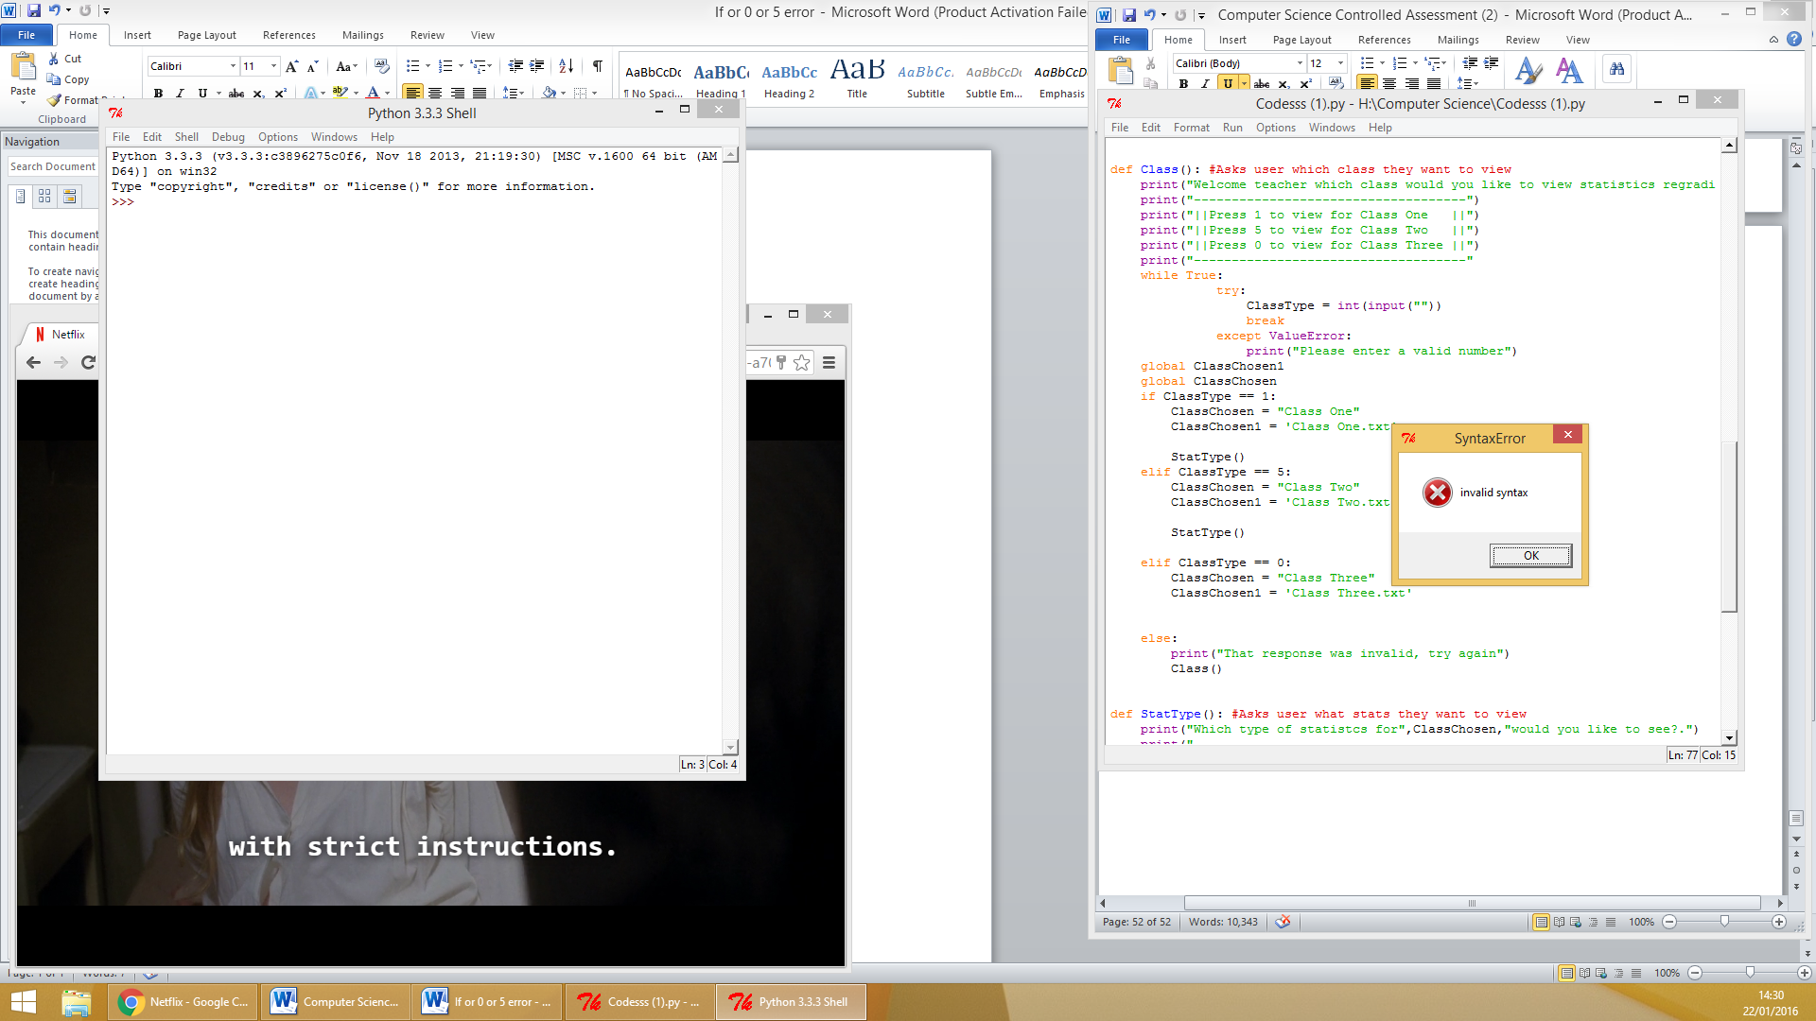  
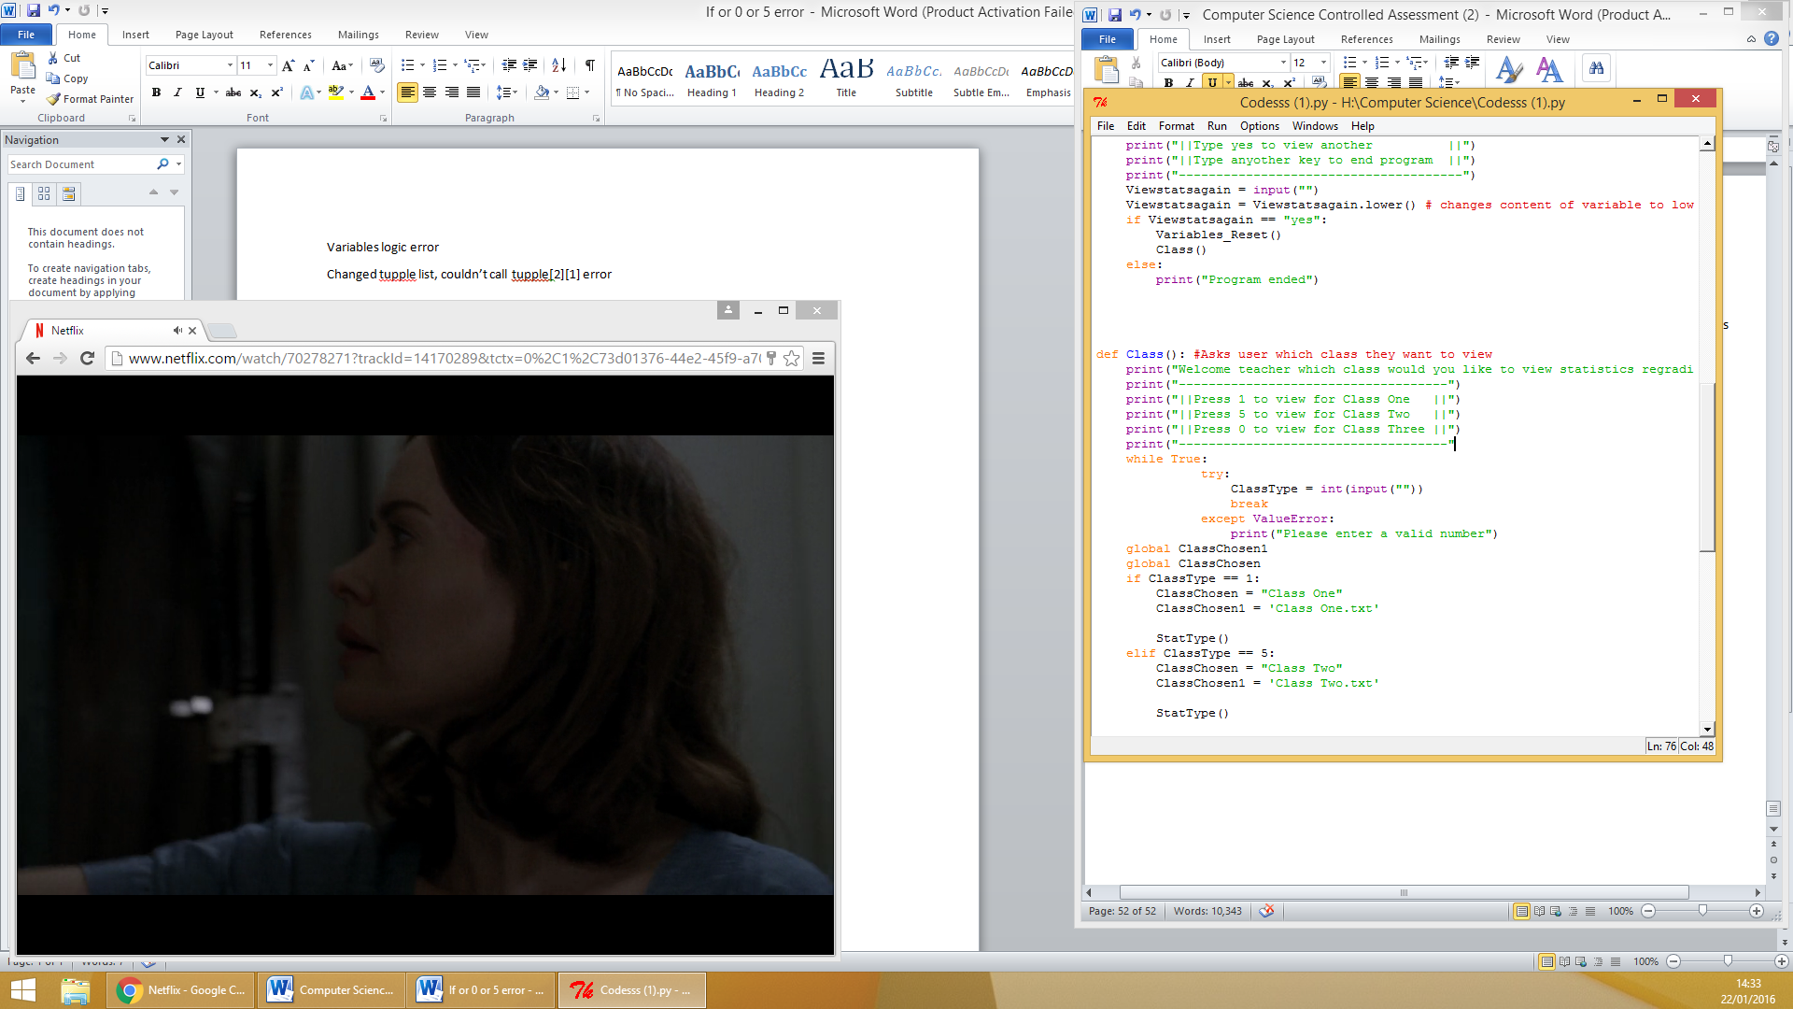

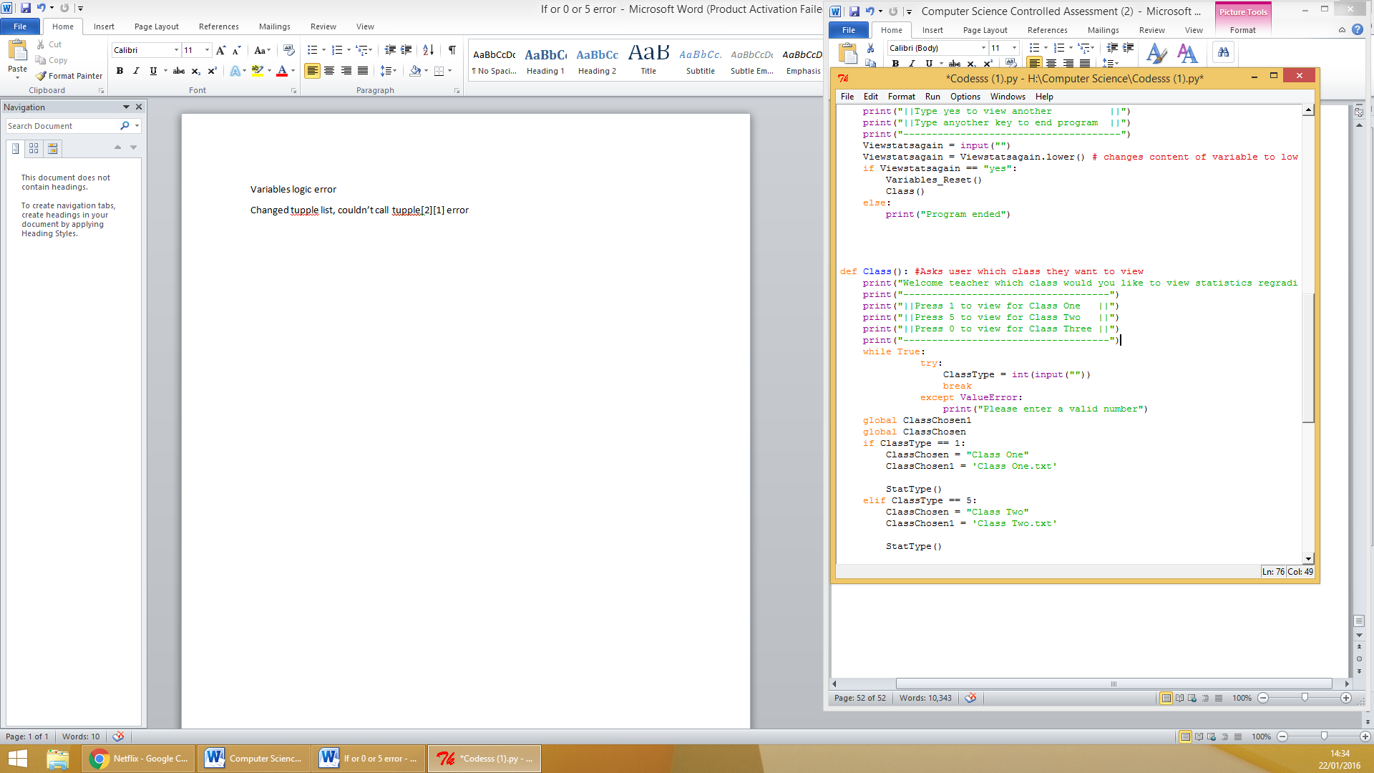

Runtime error

Logic error

